

**BAKERZ BITE**

**Supervisor:** *NGUYỄN HẠ VY*

**Semester:** *01*

**Batch No:** *T3.2403.M1*

**Group No:** *03*

|  |  |  |
| --- | --- | --- |
| **Order:** | **Full name** | **Roll No.** |
| *1.* | *NGUYEN HOANG ANH KHOA* | Student1559431 |
| *2.* | *NGO QUANG KHANH* | Student1559589 |
| *3.* | *LE VINH KHANG* | Student1559593 |
| *4.* | *NGUYEN ĐUC HUY* | Student1559421 |

***Month****: 7* ***Year****: 2024*



This is to certify that

**Mr. NGUYEN HOANG ANH KHOA Mr. NGO QUANG KHANH Mr. LE VINH KHANG**

**Mr. NGUYEN ĐUC HUY**

Have successfully Designed & Developed

# BAKERZ BITE

Submitted by:

**Mr. NGUYEN HOANG ANH KHOA**

Date Of Issue:

29 – JULY - 2024

Authorized Signature:

**Mr. NGUYEN HOANG ANH KHOA**

**Acknowledge**

This website design project for Bakerz Bite has been an incredible learning experience. Through this project, I have gained valuable insights into various aspects of web development:

* **Enhanced Technical Skills**: Improved proficiency in HTML, CSS, JavaScript, and React for building responsive and dynamic web pages.
* **User Experience Focus**: Gained understanding of user-centric design principles, enhancing the overall usability and accessibility of the website.
* **Functional Integration**: Learned to incorporate various features such as payment gateways, interactive elements, and navigation systems seamlessly.
* **Problem-Solving Abilities**: Developed strong problem-solving skills by troubleshooting and debugging issues that arose during the design and development phases.
* **Project Management**: Improved project management skills through planning, organizing, and executing tasks effectively within deadlines.
* **Collaboration and Communication**: Enhanced ability to collaborate with team members and communicate effectively with stakeholders to ensure project success.
* **Aesthetic Design**: Cultivated a keen eye for design aesthetics, ensuring that the website is visually appealing and aligns with the brand identity of Bakerz Bite.
* **Real-World Application**: Gained practical experience by working on a real-world project, preparing for future professional challenges in web development.

I would like to extend my heartfelt gratitude to Apptech Education Group for providing this opportunity to showcase and develop my web design skills. Their support has been instrumental in the successful completion of this project.

A special thanks to Ms. Ha Vy for her continuous guidance and assistance throughout the web development process. Her expertise and encouragement have been invaluable to my growth and understanding in this field.

Yours Sincerely, Team Group 03.

**Essential Library Installations**

**for React Project Setup**

Before running the React project, please ensure to install the following libraries. These installations are crucial for the project to start and function correctly.

**1. @emailjs/browser**

npm install @emailjs/browser

**2. Firebase**

npm install firebase

**3. idb**

npm install idb

**4. qrcode.react**

npm install qrcode.react

**5. leaflet and react-leaflet**

npm install leaflet react-leaflet

**6. jspdf and jspdf-autotable**

npm install jspdf jspdf-autotable

**Student Reflections on Designing**

**a Unique Bakery Website**

This website represents the culmination of significant student effort in creating a compelling online presence for a bakery. Designed to effectively showcase the bakery’s products and engage customers, the site blends creativity with practical functionality. While the visual design may not yet be as polished as other websites, and there are areas for refinement, the website’s functionality promises to surpass previous student-designed websites.

We specifically invite feedback from the faculty at the AppTech Group in India as well as the faculty at FPT Aptech. Your insights can be submitted directly via email or through the "Contact Us" section on the website. Your valuable input will be greatly appreciated and will help in making further improvements. We look forward to your comments and are eager to implement changes based on your feedback.

Written by Nguyen Hoang Anh Khoa

**Objectives of the project**

The Objective of this program is to give a sample project to work on real life projects. These applications help you build a larger more robust application.

The objective is not to teach you JSON/JavaScript/Dreamweaver/HTML5 but to provide you with a real life scenario and help you create basic applications using the tools.

You can revise the chapters before you start with the project.

This project is meant for students who have completed the module of ***HTML5***. These programs should be done in the Lab sessions with assistance of the faculty if required.

It is very essential that a student has a clear understanding of the subject. Students should go through the project and solve the assignments as per requirements given.

Kindly get back to eProjects Team in case of any doubts regarding the application or its objectives.

**Problem Definition**

Since its launch, “**Bakerz Bite**” has developed into a reputable bakery & café, specializing in baked goods, passionately made from the finest ingredients.

Bakerz Bite offers a wide range of baked goods made fresh in-store every day. The bakery chain offers more than 300 different kinds of baked goods, including artisan pastries, gourmet cakes and desserts, and handcrafted beverages.

The brand takes pride in sourcing and using carefully selected ingredients and promises to bring freshness and quality to its customers. Bakerz Bite continues to expand and embrace innovation in all markets.

We believe and are dedicated in delivering premium quality products. So we only use real butter, cream and unbleached flour. We treat our Customers as our family and will not use any ingredient which we will not want to feed ours.

*Our Motto: Where smiles are served daily.*

You are supposed to create a Single-Page-Application and responsive Website for them with the below mentioned requirement specifications.

The website should work well in all leading browsers including Chrome, IE, Firefox etc.

**Requirement Specification:**

The portal will be designed as a Single-Page-Application and responsive Website with a set of pages and menus that represent choice of activities to be performed. The pages, menus, and other visual elements must be designed in a visually appealing manner with attractive fonts, colors, and animations.

All of these should also be laid out in a responsive manner

The Web site is to be created based on the following requirements.

1. The Top of the Page should be presented with a suitable logo and a banner with images of Cakes, Pastries, Cookies etc.
2. The site must contain sections like Cakes, Pastries, Cookies, Pies etc. and should consist various items.
3. Clicking on any item should open pop-up window with images of product along with the description and detailed specification (ingredients).
4. Site should also consist of a section “Merchandise’ with “Bakerz Bite” branded Mugs, Bags, Glasses, Trays listed into it.
5. Filters should be provided for assisting user to select products of their choice.
6. Gallery should be added for viewing different images.
7. Feedback and Rating must be allowed to enter by the viewer
8. Site map, Gallery, about us, FAQ link, Contact us link must be added.
9. About Us and Contact Us: This menu option should display Email id, address, and contact number.
10. Section for various offers in the store should be provided with listing of offers with details.
11. Color combination must be uniform throughout the project.
12. Navigation must be smooth.

Over and above this, the portal should implement the following functionalities:

* Display a continuous scrolling ticker at the bottom of the page with current date, time, and location (hint: Use geolocation features of HTML5).
* Display a visitor count at the top right corner of the page beside a logo image.
* The menu options should change color on hover and also after clicking.
* Fade in and fade out options can be used for the menus.

**Customer Requirements Specifications**

**Hardware**

* Intel Core i3/i5 Processor or higher
* 8 GB RAM or above
* Color SVGA
* 500 GB Hard Disk space
* Mouse
* Keyboard

**Software**

Technologies to be used:

* Frontend: HTML5, CSS, Bootstrap, JavaScript, jQuery, React/AngularJS, Figma, XML
* Data Store: JSON files or TXT files

Other Requirements:

* Operating Portal: Windows
* Browsers: Edge, Chrome, Mozilla Firefox, Safari

**Project Deliverables**

You will design and build the project and submit it along with a complete project

report that includes:

• Problem Definition

• Design specifications

• Diagrams such as flowcharts for various activities, Data Flow Diagrams etc.

• Source Code

• Test Data Used in the Project

• Project Installation Instructions (if any)

Documentation is considered as a very important part of the project. Ensure that documentation is complete and comprehensive. The consolidated project will be submitted as a zip file with a ReadMe.doc file listing assumptions (if any) made.

**Submit a video clip demonstrating the working of the Website.** Optionally, a live hosted URL can be supplied for the site. Over and above the given specifications, you can apply your creativity and logic to improve the portal.

**Architecture and design of the project**

**HEADER**

**FOOTER**

**Table of Contents**

**I- Landing Page**

**II- Home Page**

**2.1. Navbar**

**2.1.1. Search Function**

**2.1.2. Calculation Visitors**

**2.1.3. Login Function**

**2.2. Main Slider Section**

**2.3. About Us Section**

**2.4. New Product Section**

**2.5. Top Selling Section**

**2.6. Our Baker Section**

**2.7. Why Choose Us Section**

**2.8. Promotion Section**

**2.9. Blog Section**

**2.10. Testimonials Section**

**2.11. NewsLetter Section**

**III- Menu**

**3.1. List Box**

**3.2. List Product**

**IV-Product Display Page**

**4.1. Add to wishlist**

**4.2. Compare**

**4.3. Share**

**4.4. Product Information**

**4.5. Related Products**

**4.6. Add to cart**

**4.7. Buy Now**

**4.8. User Page**

**V-Cart Page**

**5.1. Discount coupon**

**5.2. Reward Point**

**VI- Payment Page**

**6.1. Form**

**6.2. Policy**

**VII- Blog Page**

**7.1. Detailed post page**

**7.2. File audio**

**7.3. Share and Write comments**

**VIII- Gallery Page**

**IX- About Us Page**

**X- Contact Us Page**

**XI- Login and Signup Page**

**11.1-Login**

**11.2. Signup**

**XII- Footer**

**12.1. Links**

**12.1.1. Home**

**12.1.2. Branch**

**12.1.3. FAQ**

**12.1.4 Social Links**

**12.1.5. Virtual Assistant Page**

**XIII- Other Features**

**13.1. Back to top  
  
13.2. Display time date and location**

**13.3. Translate**

**I-Landing Page**

This initial page serves as a warm introduction to our bakery, offering a preview of our delicious offerings. From here, you can click the "Visit Our Website" button to access the main site, where you'll find a comprehensive menu, engaging blog, vibrant gallery, and more. We’re thrilled to showcase our work and look forward to your exploration of the Bakerz Bite experience!

This is Landing Page:

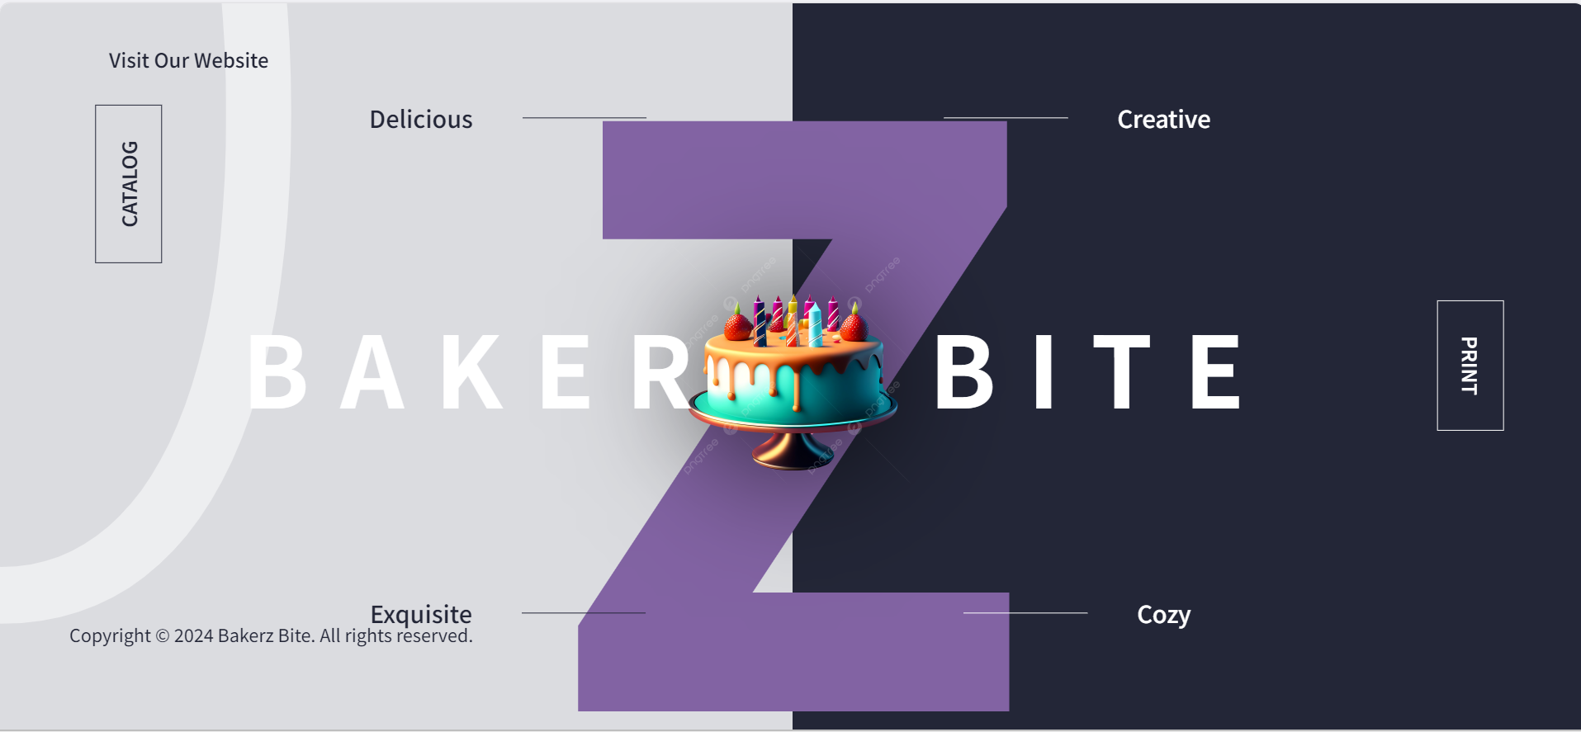

**Icon Confirmation on the Official Bakerz Bite Website**

When you visit the Bakerz Bite website, you'll notice the Bakerz Bite icon prominently displayed on the search bar. This icon serves as a confirmation that you are on the official Bakerz Bite website, ensuring an authentic and secure browsing experience.



**II. Home Page**

Our Home page is designed to introduce you to the heart of Bakerz Bite and enhance your experience with us. This central hub provides a comprehensive overview of our bakery and its offerings:

Below is an overview of the Home page for the project.

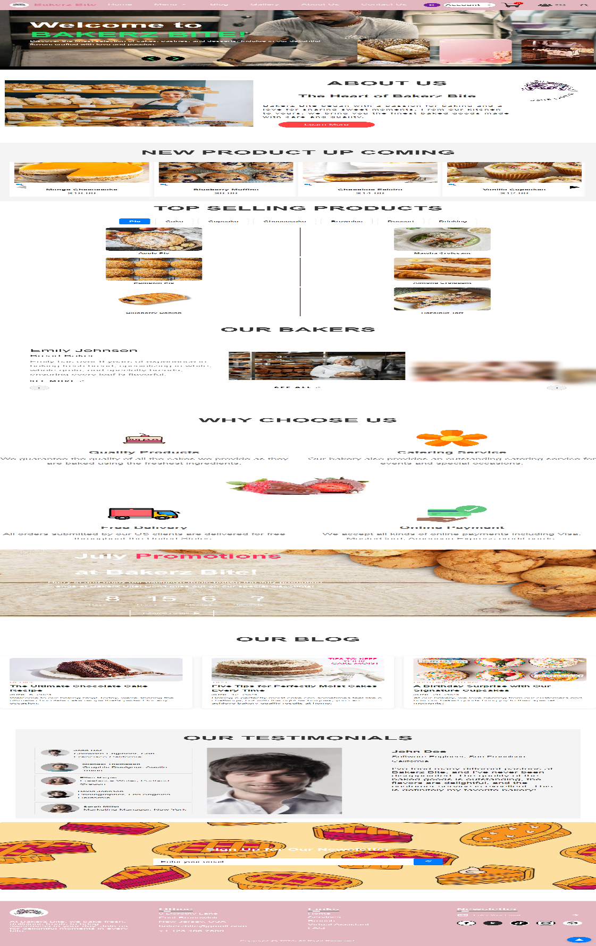

**2.1. Navbar**

**2.1.1. Search Function**

The navbar for the Bakerz Bite website is designed to provide seamless navigation and enhance user experience. It includes key sections to help visitors easily find their way around:

* **Home**: Returns users to the main landing page.
* **Menu**: Showcases our range of products including Pies, Cake, Cupcake, Cheesecake, Brownies, Drinking, and Merchandise.
* **Blog**: Provides access to our latest posts, recipes, baking tips and our customer story.
* **Gallery**: Displays a curated collection of our product images.
* **About Us**: Shares the story behind Bakerz Bite and our commitment to quality.
* **Contact Us**: Offers a way to reach out for inquiries and feedback.
* **Login**: Allows users to manage their accounts and view orders.
* **Search**: Enables users to quickly find specific products and content.



To easily find a specific product from our bakery, you can use the search feature available on our site. Simply click on the search icon, and a search bar will appear. Enter the name of the bakery item you're looking for, and the search results will dynamically update to show matching products.

The search results will display:

* **Product Name**: The name of each matching item.
* **Price**: The price of each product. During our ongoing July discount program, you will see the old price struck through, with the new discounted price shown.
* **Number of Results**: The total number of products found based on your search criteria.

If you wish to view more details about a particular product, you can click on any item in the search results. This will direct you to the Product Display page, where you can find comprehensive information about the selected item, including detailed descriptions and images.

This search functionality ensures a streamlined and efficient way to explore our bakery’s offerings and find exactly what you're looking for while taking advantage of our current promotions.

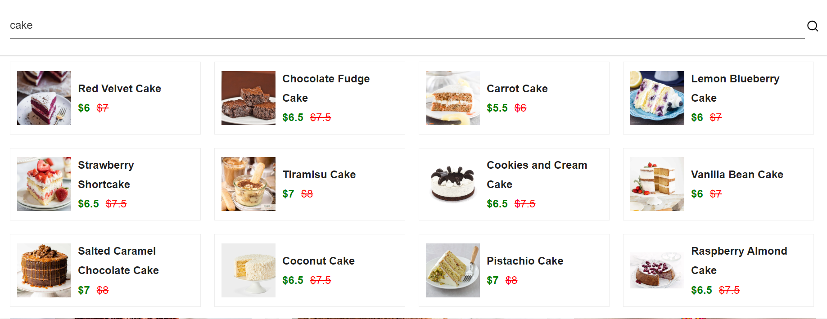

**2.1.2. Calculation Visitors**

Our website features a dynamic visitor count display to keep track of the number of active users. In the top right corner of the page, you'll see an icon of a person with a number displayed next to it. This number represents the current number of visitors on the site.

**Key Functionality:**

* **Dynamic Count:** The number displayed automatically updates to reflect the number of people currently accessing the site.
* **Real-Time Updates:** As new visitors enter the site, the number will increment to show the current visitor count, providing a live snapshot of site activity.



Before After

**2.1.3. Login Function**

Located in the top right corner of the page, the Login button enables users to access their personal accounts. Clicking this button will direct you to the login page where you can enter your username and password to sign in.

**User Icon:** After logging in, the Login button will transform into an icon representing your user account. This icon provides a visual indication that you are signed in and offers quick access to your account settings and personalized features.

**2.2. Main Slider Section**

Our Main Slider serves as a warm introduction to our bakery and its offerings. This interactive feature showcases a series of engaging slides that highlight different aspects of our business.

**Key Features:**

* **Slide Navigation:** Use the arrows at the bottom of the slider to navigate through the slides. You can move left or right to view different slides.
* **Unique Content:** Each slide features a distinct title and content, providing varied insights and highlights about Bakerz Bite.
* **Dynamic Presentation:** The slider offers a dynamic and visually appealing way to present key information and promotions.

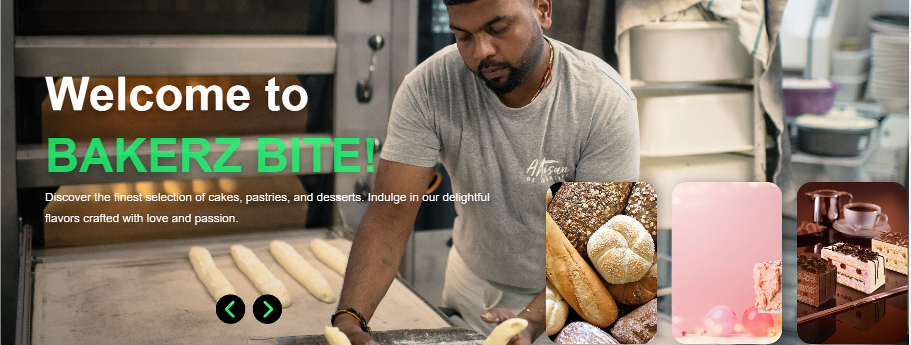

**2.3. About Us Section**

**About Us** section offers a glimpse into the heart and soul of our bakery. Here, you’ll discover our story, values, and the passion that drives us to deliver the finest baked goods.

To learn more about our journey, values, and what makes us unique, click on the **"Learn More"** button. This will provide you with detailed information about our story, our commitment to quality, and our mission behind Bakerz Bite.

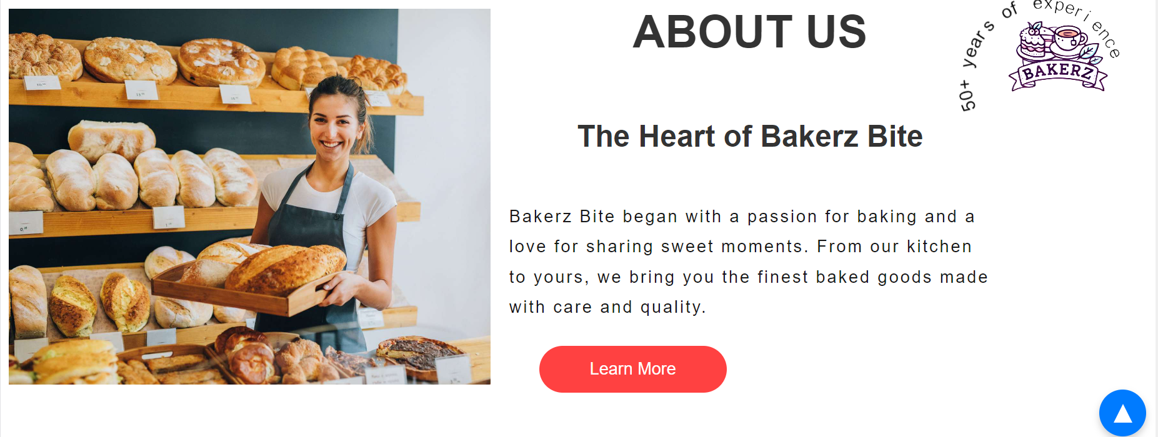

**2.4. New Product Section**

In the **New Products** section, you’ll find a preview of the delicious treats we’ll be offering throughout August. Each featured item includes a preview image and the estimated price.

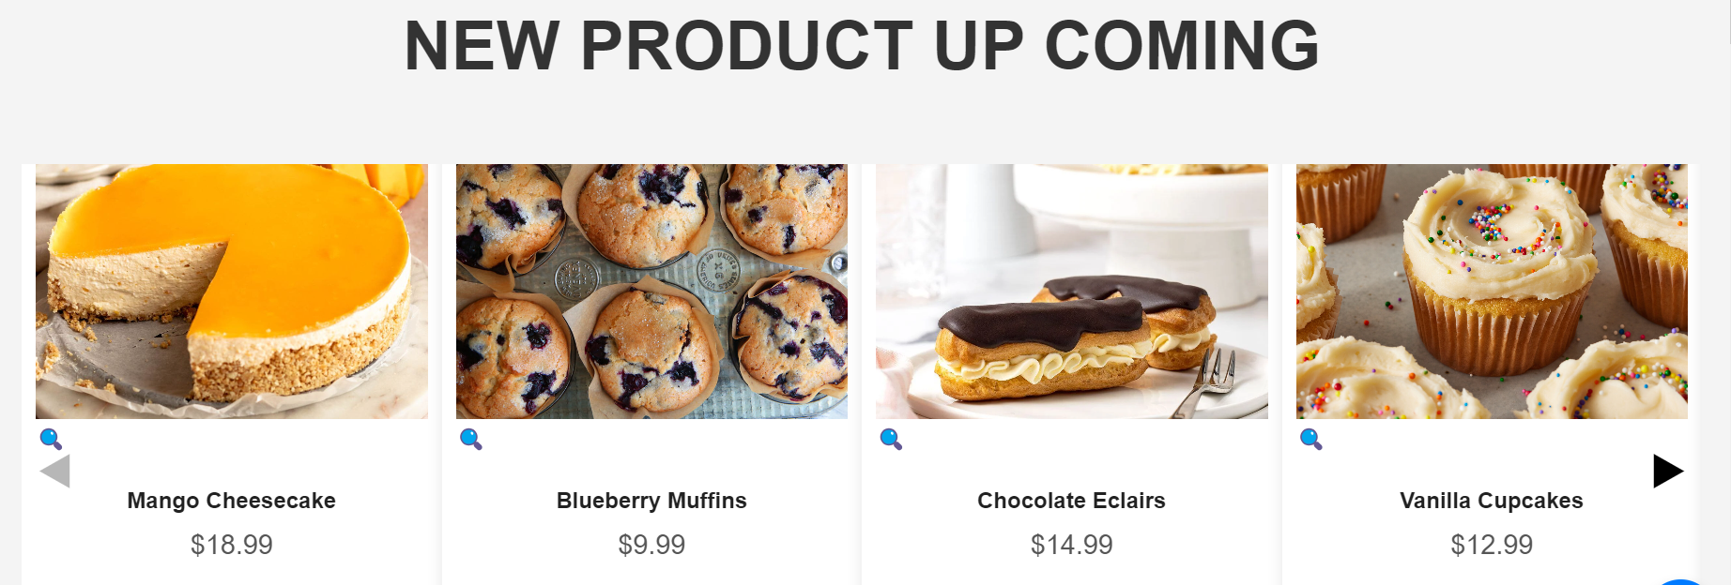

**Key Features:**

* **Image Navigation:** Use the arrow icons to scroll through the product images and get a glimpse of our upcoming offerings.
* **Enlarged View:** Click the magnifying glass icon to view a larger, more detailed image of each product.

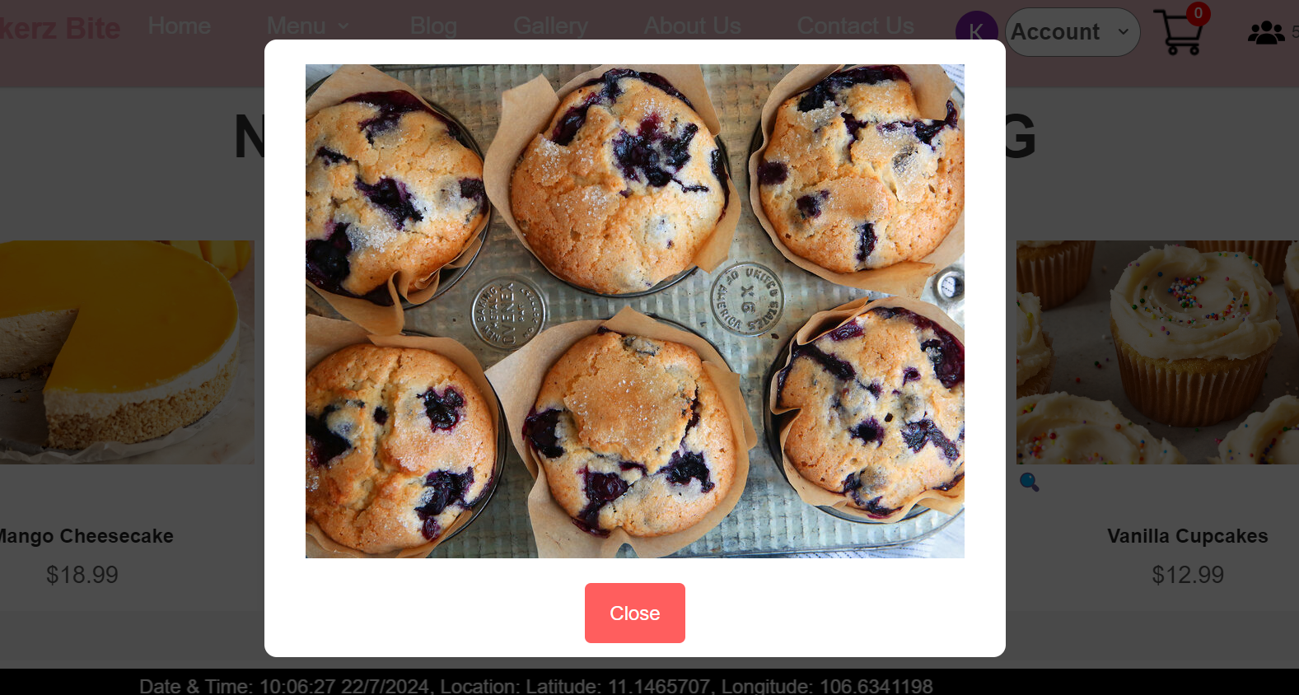

* **Product Details:** Click on the product title to read a comprehensive description.

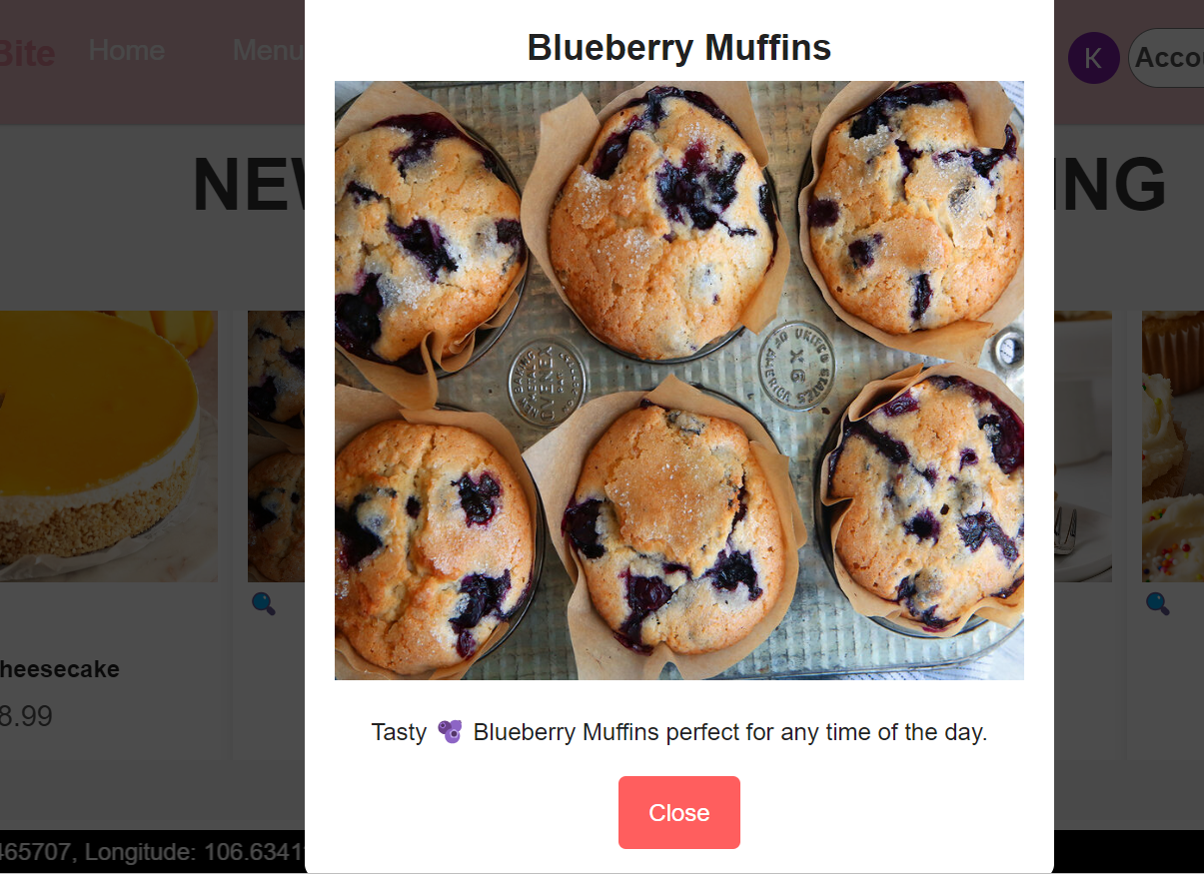

**2.5. Top Selling Section**

In the **Top Selling** section, you can explore the most popular items at Bakerz Bite. This section showcases our best-selling products, so you know exactly what’s hot right now.

**Key Features:**

* **Category Navigation:** Use the buttons to filter products by categories such as Pies, Cake, Cupcake, Cheesecake, Brownies, Desserts and Drinking. Clicking on a category will display the top-selling items specific to that selection.
* **Product Details:** Click on any product to view detailed information, including ingredients, pricing, and more, on the Product Display page.

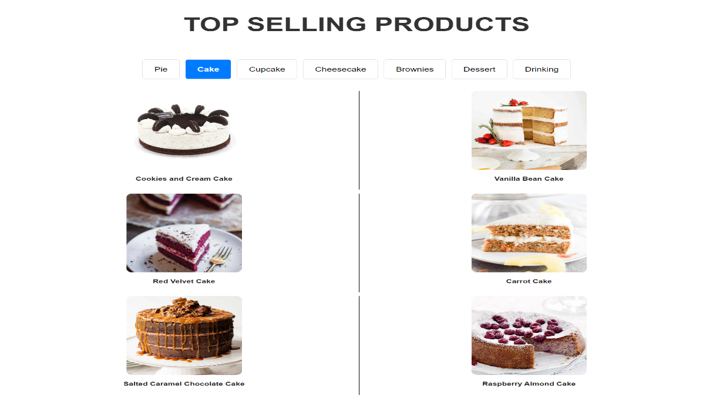

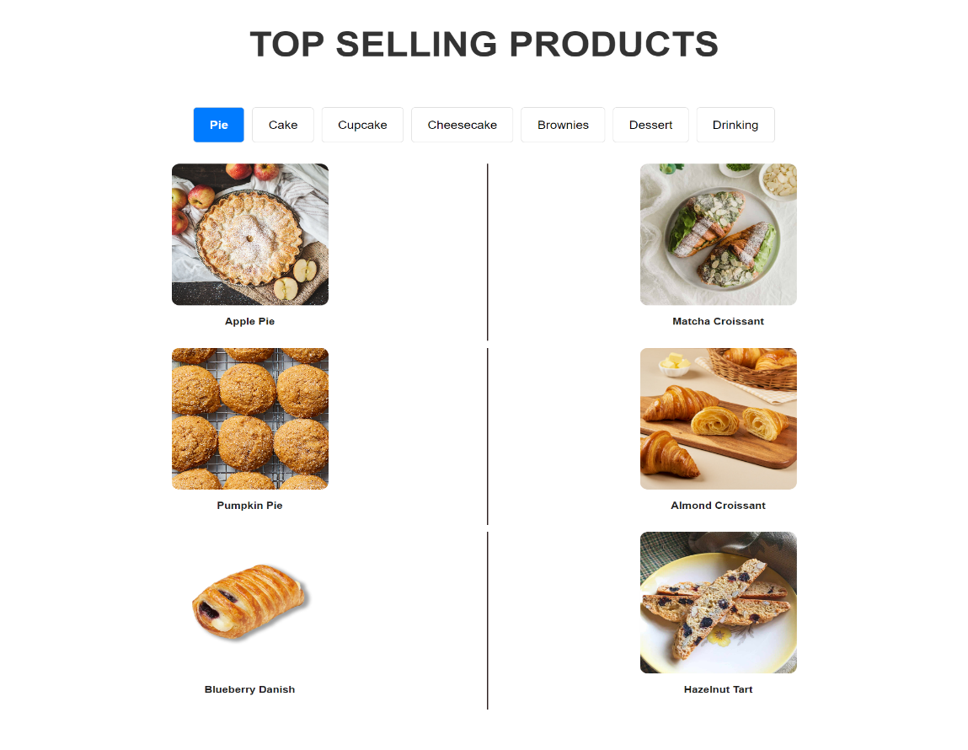

**2.6. Our Baker Section**

In the **Our Baker** section, you’ll get to know the talented bakers who bring the delicious creations at Bakerz Bite to life. Discover the names and backgrounds of our skilled bakers, along with a brief introduction to their experience and expertise.

To dive deeper into their personal insights, click on the **"See More"** button. This will reveal more about their journey, their passion for baking, and what drives them to create the exceptional treats you love.

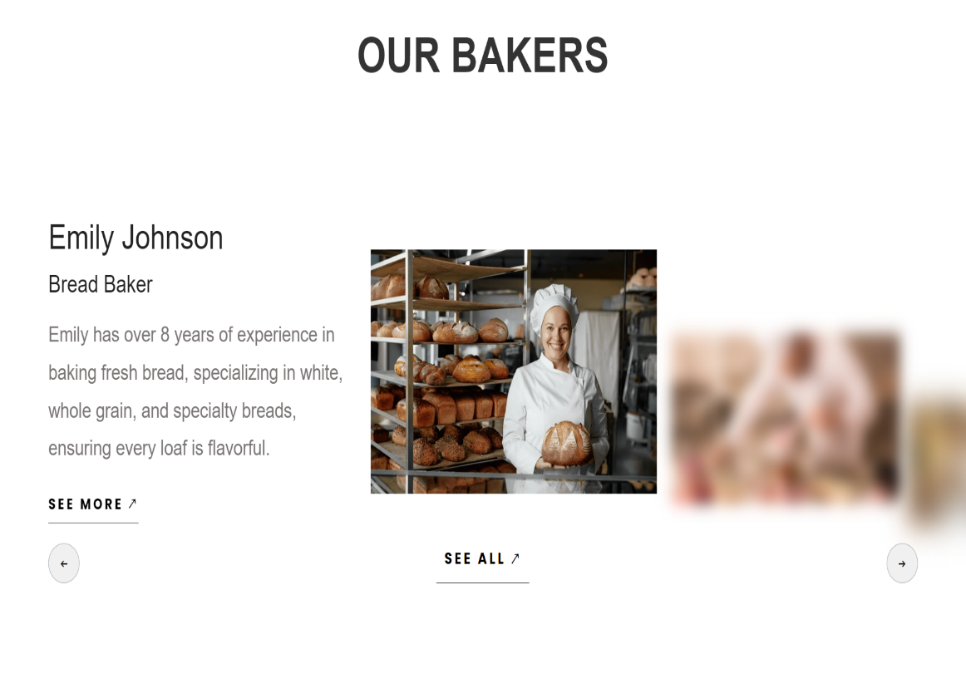

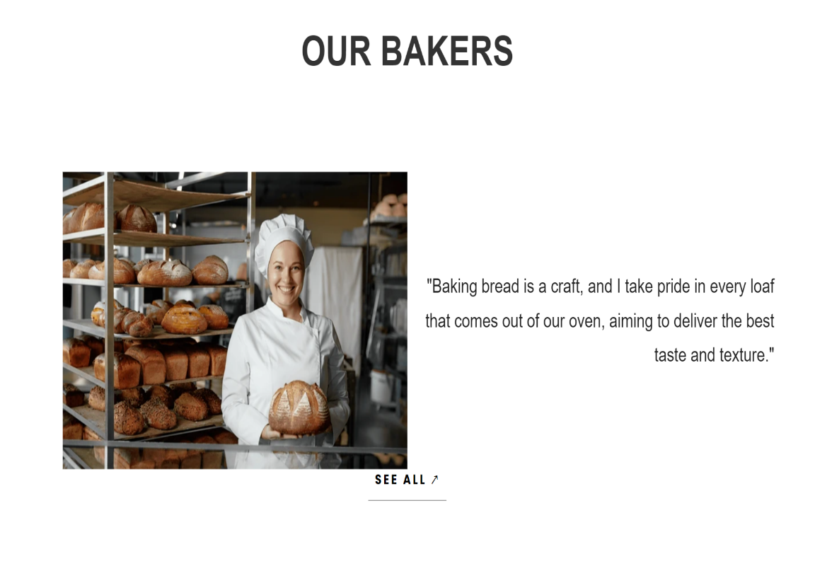

**2.7. Why Choose Us Section**

When you visit our website, the "Why Choose Us" section is designed to immediately highlight the key benefits of choosing Bakerz Bite. Here’s how this section enhances your experience:

**Showcasing Our Commitment to Quality**  
By emphasizing our dedication to using the freshest ingredients and delivering high-quality baked goods, we assure customers of the superior taste and craftsmanship they can expect. This builds confidence and encourages customers to make a purchase, knowing they’re getting top-notch products.

**Highlighting Our Comprehensive Services**  
Our catering service is prominently featured, which helps attract potential clients looking for exceptional solutions for their events. By showcasing our ability to customize offerings for special occasions, we position ourselves as a versatile choice for a range of needs.

**Offering Convenience with Free Delivery**  
The mention of free delivery throughout the United States adds significant value to our service. It removes a potential barrier to purchase by eliminating shipping costs, making it easier for customers to choose our bakery for their needs.

**Ensuring Secure and Easy Transactions**  
By listing our acceptance of various online payment methods, we provide customers with the flexibility and security they seek when shopping online. This reassurance helps facilitate smoother transactions and enhances the overall shopping experience.

The "Why Choose Us" section not only informs visitors about our unique selling points but also instills trust and encourages them to explore our offerings further. It sets the stage for a positive user experience, making it clear why Bakerz Bite is the preferred choice for quality baked goods and exceptional service.

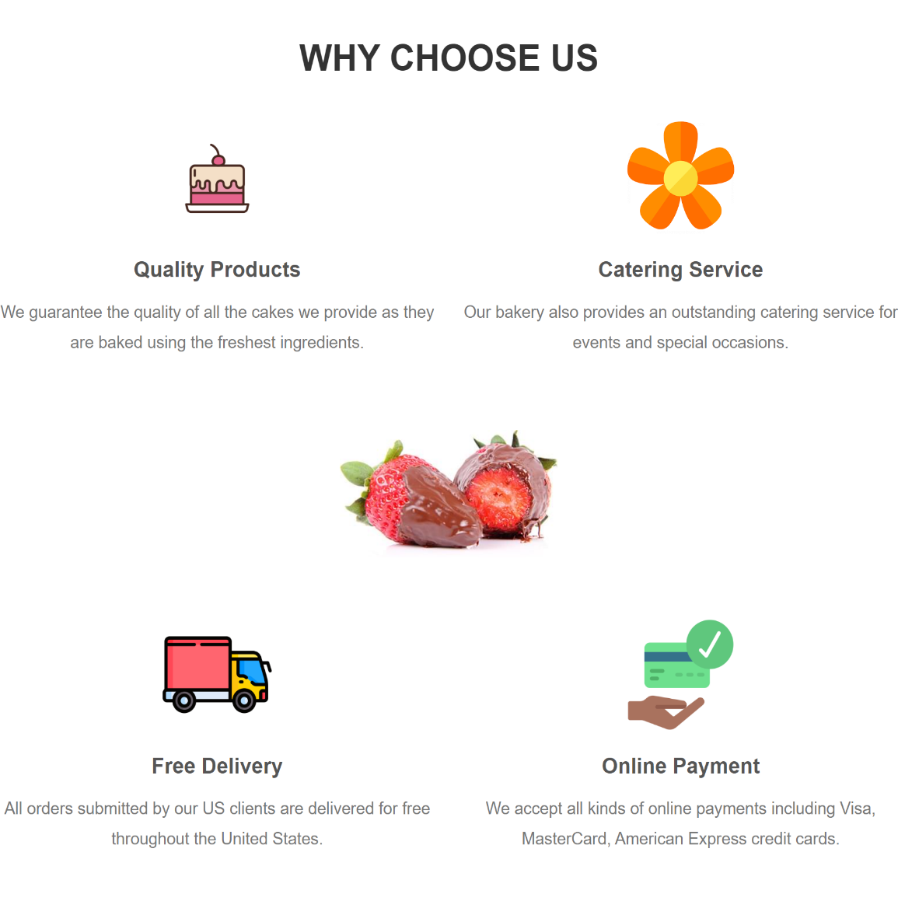

**2.8. Promotion Section**

Welcome to our Promotion section, where you can find all the details about our special offers for July. We’re thrilled to bring you exclusive deals and discounts that make your experience with Bakerz Bite even more delightful. Here’s what you need to know:

**Current Promotions**  
Our July promotions feature fantastic discounts on a wide range of products. This is your chance to enjoy your favorite treats at reduced prices. To keep you informed, we have a countdown timer prominently displayed, showing the exact number of days remaining for each promotion. This countdown helps you keep track of the time left to take advantage of these offers.

**Stay Informed**  
For more details about each promotion, simply click the "Search Details" button. This will trigger a popup window that provides comprehensive information about the current deals, including specific discounts, eligible products, and terms and conditions. This feature ensures you have all the information you need to make the most of our special offers.

The Promotion section is designed to keep you updated on our latest deals and create a sense of urgency to take advantage of the savings before time runs out. Enjoy our exclusive offers and happy shopping!

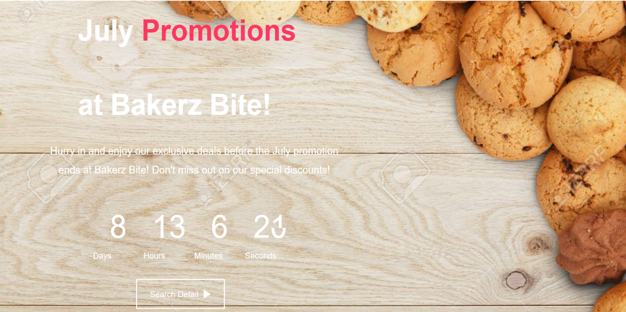

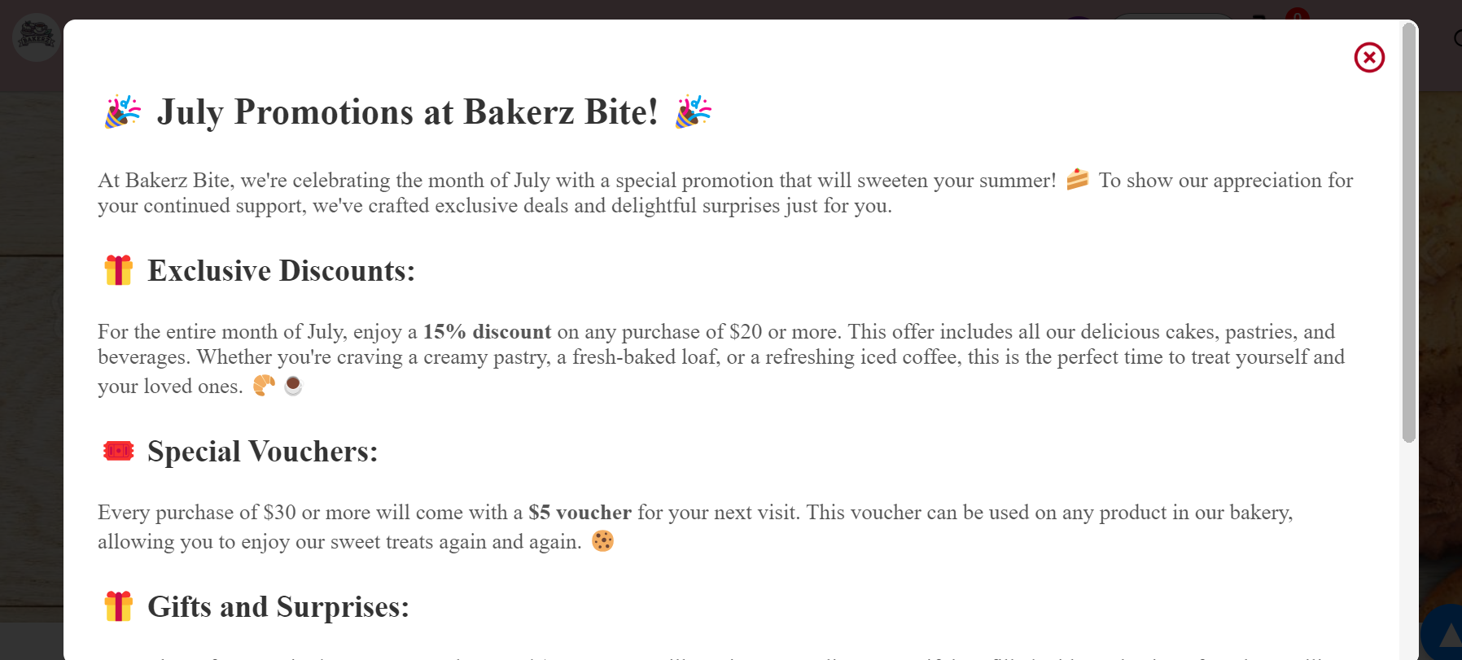

**2.9. Blog Section**

Welcome to our Blog section, your go-to source for all things baking at Bakerz Bite. Here, you’ll find a variety of engaging and informative content designed to inspire and educate our readers.

**What You’ll Find**

* **Recipe:** Discover expert tips, tricks, and detailed step-by-step recipes that will elevate your baking skills. Our blog provides creative ideas and professional advice to help you bake like a pro, whether you're a novice or an experienced baker.
* **Tips:** Explore our collection of baking tips designed to enhance your kitchen prowess. From practical advice to innovative techniques, our blog shares valuable insights that will help you perfect your baking and create delicious results every time.
* **Customer Story:** Immerse yourself in the stories of our customers and learn how our baked goods have played a special role in their lives. These heartfelt accounts offer a unique perspective on the impact of our treats and the joy they bring to special occasions.

**How to Explore**

* **View Posts:** Click on any blog post title or image to dive into the full article. Each post is crafted to provide valuable insights and entertaining content that you won’t want to miss.
* **Visit Our Blog:** For a broader exploration, click the **Visit Our Blog** button. This will take you to our main Blog page where you can browse through a collection of posts, explore different categories, and stay updated with our latest content.

Our Blog section is designed to keep you informed, entertained, and inspired. Whether you’re looking for baking advice or simply want to read about the experiences of others, you’ll find plenty to enjoy and explore.

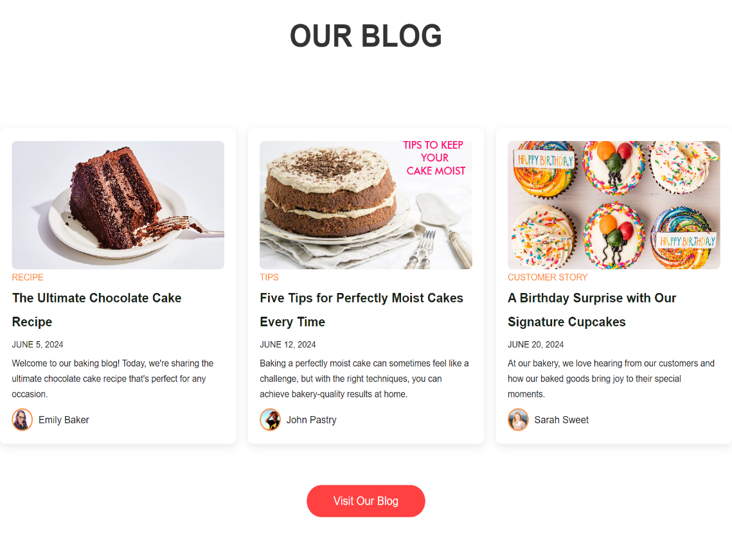

**2.10. Testimonials Section**

The Testimonial Section is designed to showcase customer feedback on Bakerz Bite’s products and services. This section provides valuable insights into how customers perceive the bakery’s offerings and helps build credibility through real experiences.

**Customer List and Feedback Display**

This section is divided into two main parts: a list of customers and a detailed view of their testimonials. The left side features a list of customers whose feedback can be viewed, while the right side displays their detailed testimonials.

**Detailed Feedback View**

When a name is selected, the feedback provided by that customer appears prominently on the right side, offering insights into their experiences with Bakerz Bite. This detailed view allows users to read about specific experiences and opinions.

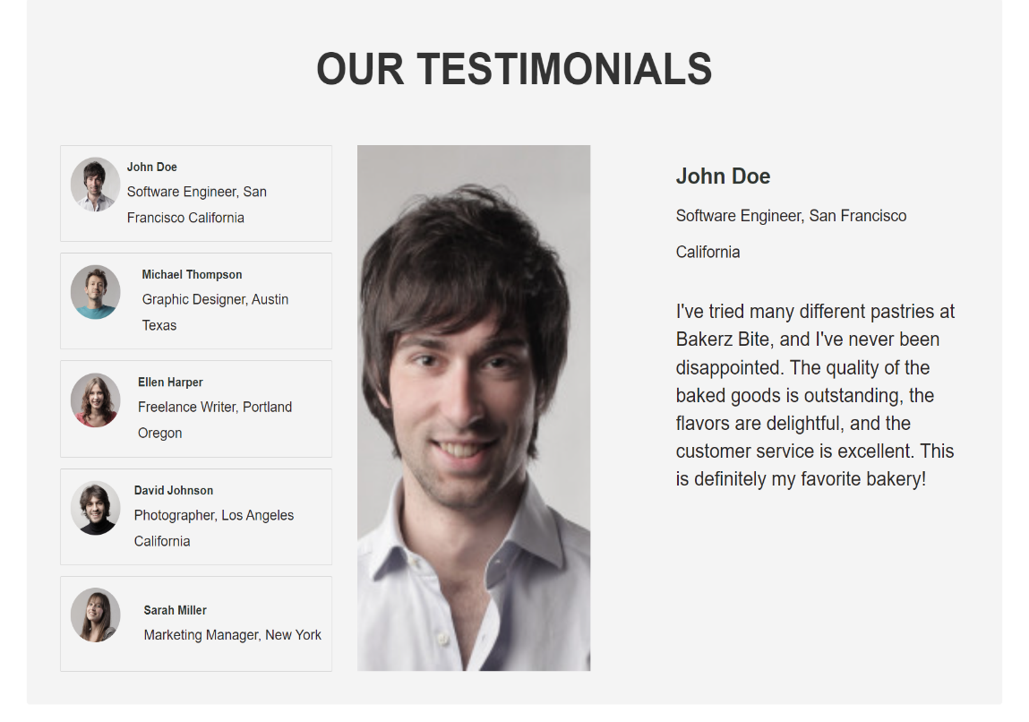

**2.11. NewsLetter Section**

The Newsletter Section is designed to keep customers informed about the latest updates from Bakerz Bite. By subscribing to our newsletter, customers can receive regular updates on new products, blog posts, and promotional offers directly to their email inbox.

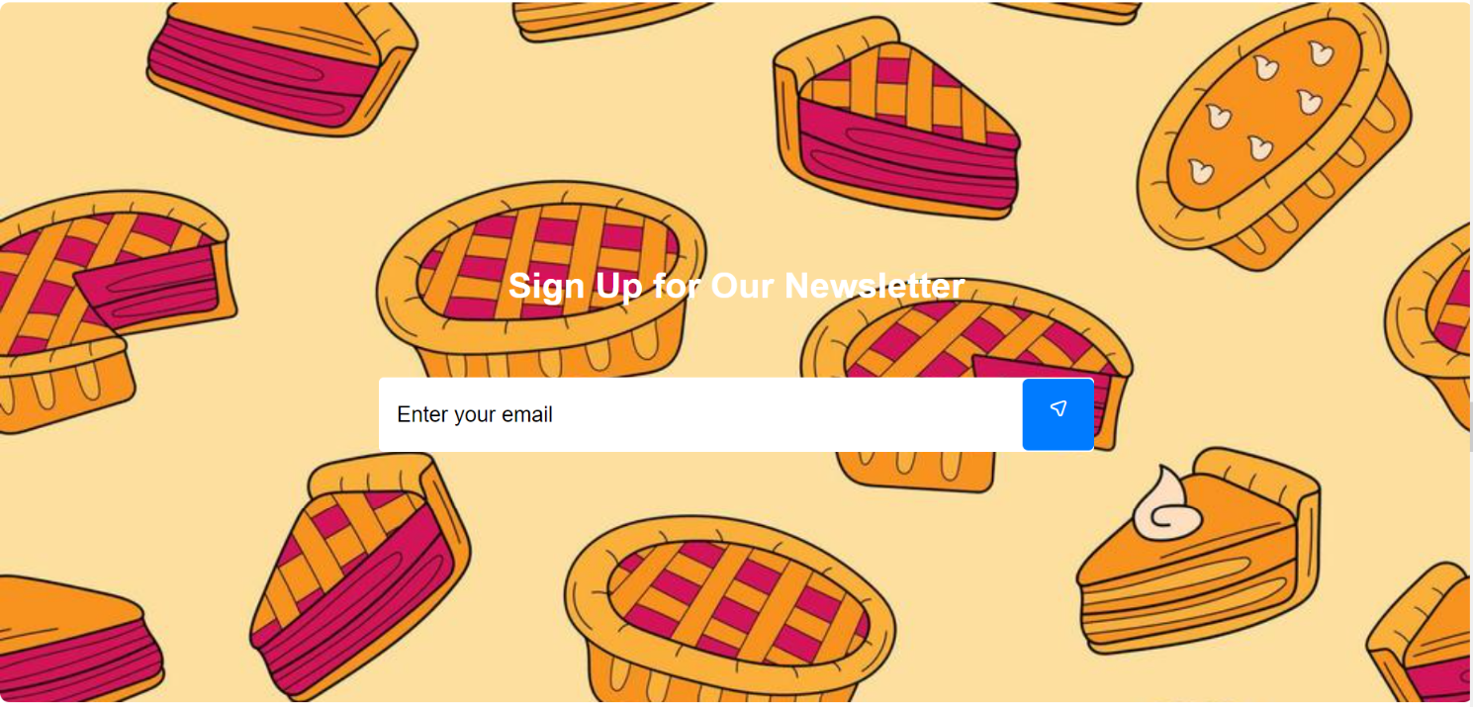

**Subscription Form**

In this section, customers are invited to enter their email address to subscribe to the newsletter. This form is easy to use and allows customers to stay connected with Bakerz Bite by receiving timely updates on various aspects of the bakery.

**Successful Subscription Notification**

Once a customer has successfully submitted their email address, they will receive a confirmation notification. This message informs them that their subscription was successful and that they can expect to receive newsletters with exciting updates.

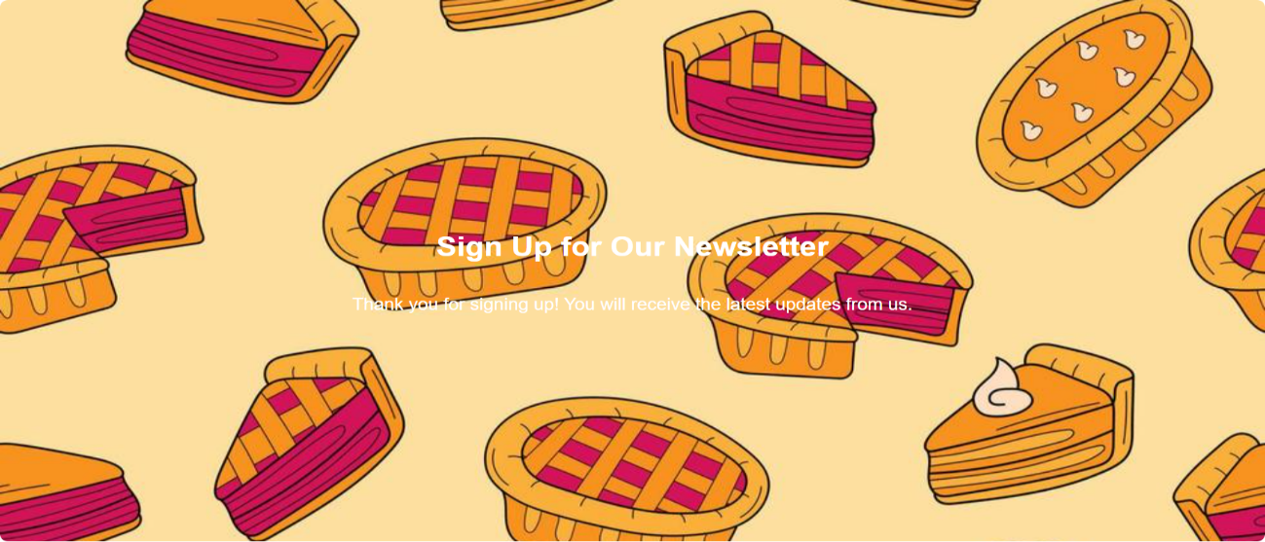

**Confirmation Email**

After subscribing, customers will receive a confirmation email from the Bakerz Bite Team. This email thanks them for subscribing and provides additional information about what they can expect from the newsletter. The email also includes a link to the Bakerz Bite website, encouraging customers to explore the bakery’s offerings further.

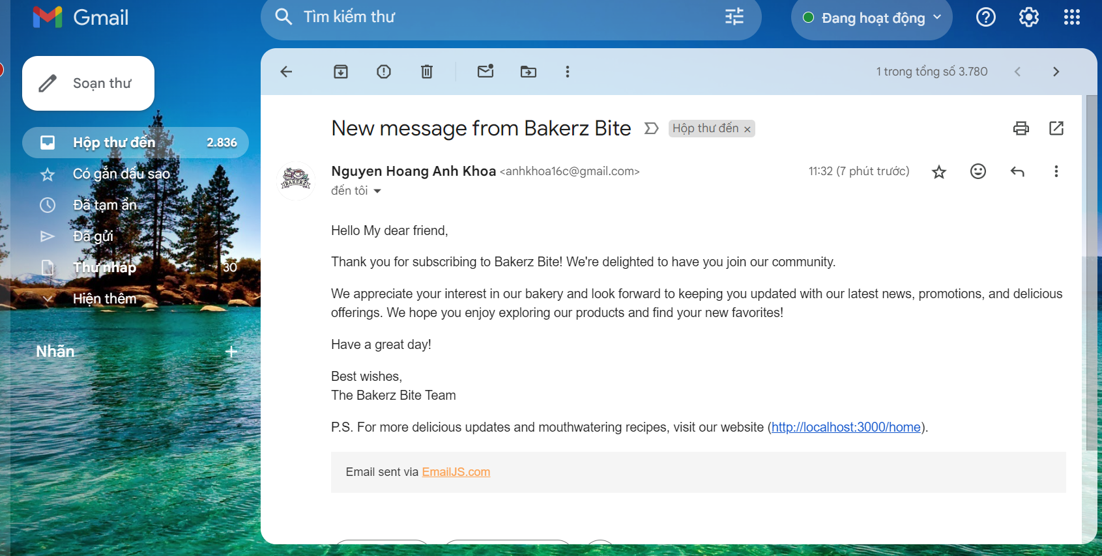

**III-Menu**

The Bakerz Bite website features a comprehensive and user-friendly menu that helps customers easily navigate through the various offerings of the bakery. Each menu item directs customers to specific sections, making it convenient for them to find exactly what they are looking for. The menu includes the following categories:

**Pies**

**Pies** section offers a delightful assortment of pies, each crafted with care and the finest ingredients. Customers can explore various flavors and find their favorite pie.

**Cake**

In the **Cakes** section, customers will discover a wide range of cakes, from classic favorites to innovative new creations. Each cake is designed to bring joy to any occasion.

**Cupcake**

The **Cupcakes** section showcases our adorable and delicious cupcakes, perfect for any celebration or just as a sweet treat. Customers can choose from a variety of flavors and styles.

**Cheesecake**

Our **Cheesecakes** section features rich and creamy cheesecakes in a variety of flavors. Each cheesecake is a perfect blend of smooth texture and delectable taste.

**Brownies**

The **Brownies** section is dedicated to our mouth-watering brownies, known for their rich chocolatey flavor and perfect texture. These treats are a hit among chocolate lovers.

**Desserts**

In the **Desserts** section, customers can explore an array of sweet delights beyond cakes and pies. From pastries to puddings, this section has something to satisfy every sweet tooth.

**Drinking**

The **Drinking** section offers a selection of beverages that perfectly complement our baked goods. Customers can choose from a variety of drinks to enjoy with their treats.

**Merchandise**

Lastly, the **Merchandise** section features a range of Bakerz Bite branded items. From apparel to kitchen accessories, customers can find unique merchandise to show their love for Bakerz Bite.

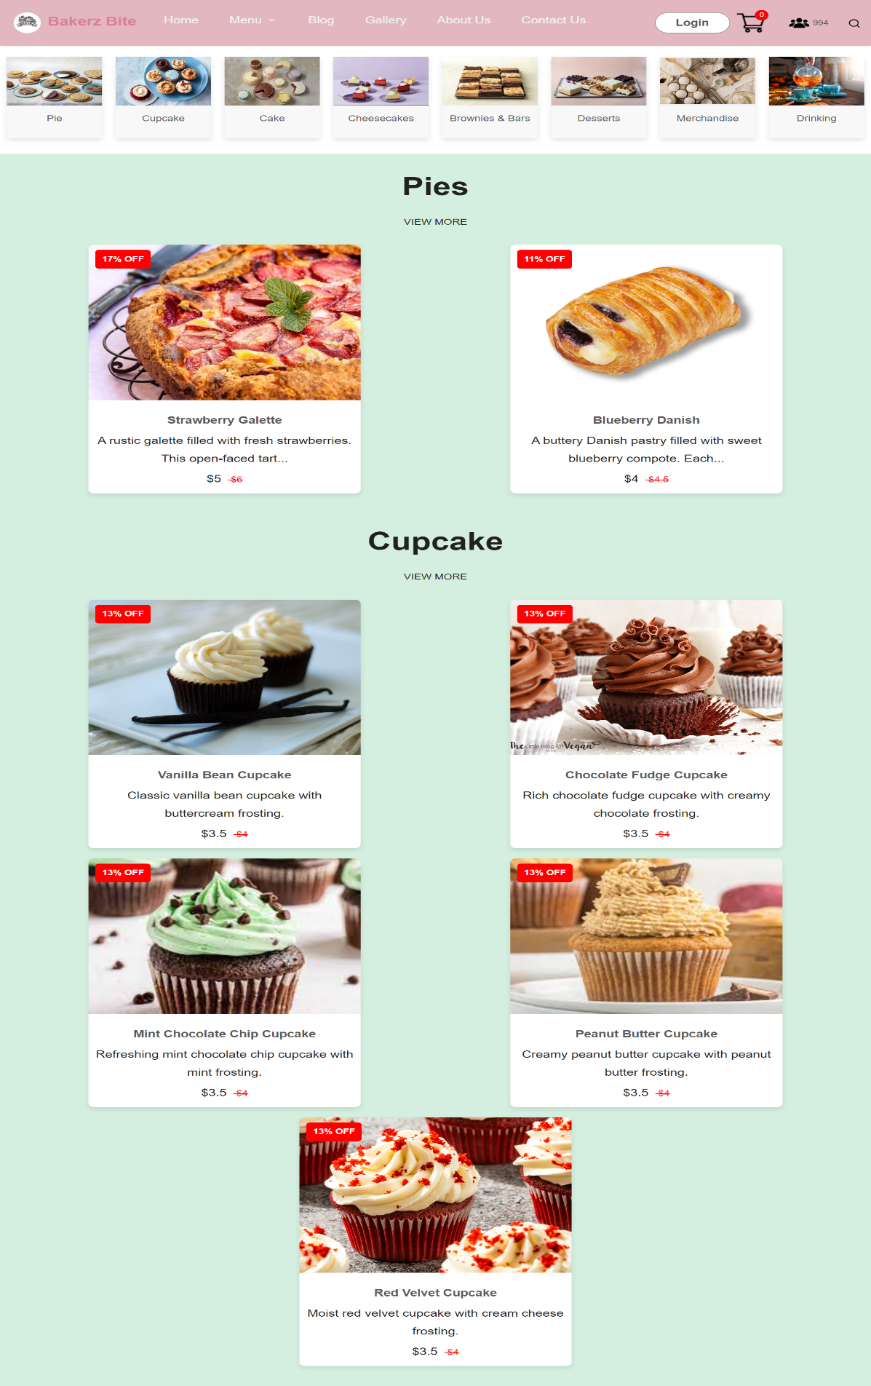

**3.1. List Box**

On our menu page, you will first see a list of products categorized specifically from Pies, Cakes, to Drinks, and more. When you click on any category, you will be taken directly to the section containing those products without having to scroll.

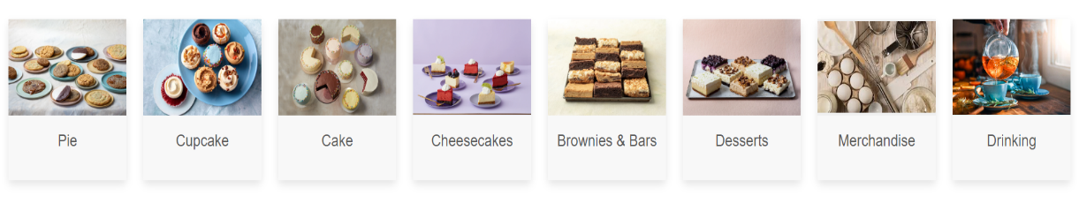

**Example Section: Pies**

In the **Pies** section, you will find some of our store's products. You can see product images, introductory information, old prices, and new prices. Each product displays the discount percentage in the top left corner so users can easily see the savings. If you want to see detailed information about a product, you can click on it and you will be taken to the **Product Display** page. To view all products in the Pies category, simply click on **View More**. Additionally, each time users access the products, they will be displayed randomly within their respective category.

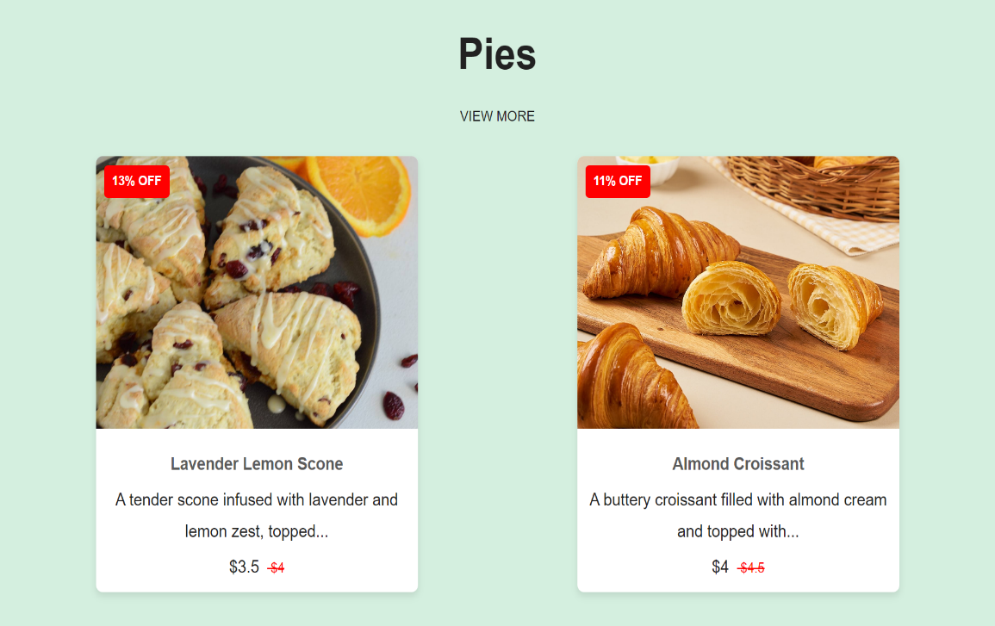

**3.2. List Product**

In addition to clicking the **View More** button to see more products, the menu will have a dropdown list with categories. You can click on any category in the dropdown list to view products in that category directly.

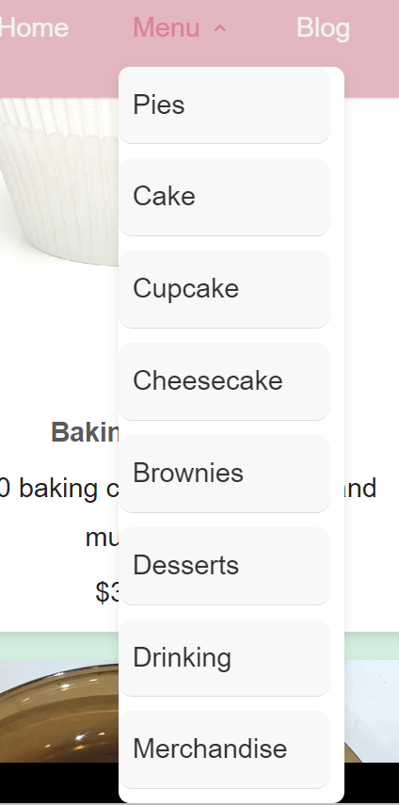

Next, I will continue with an example for the **Pies** page. After clicking into this section, you will first see a counter in the top-left corner that shows the total number of products in the Pie category. Scrolling down, you will find a **Load More** button to display additional products. Additionally, if you want to select a specific product, you can click the filter option. This will display a selection box on the right with hashtags and checkboxes to help you quickly find the product you are looking for.

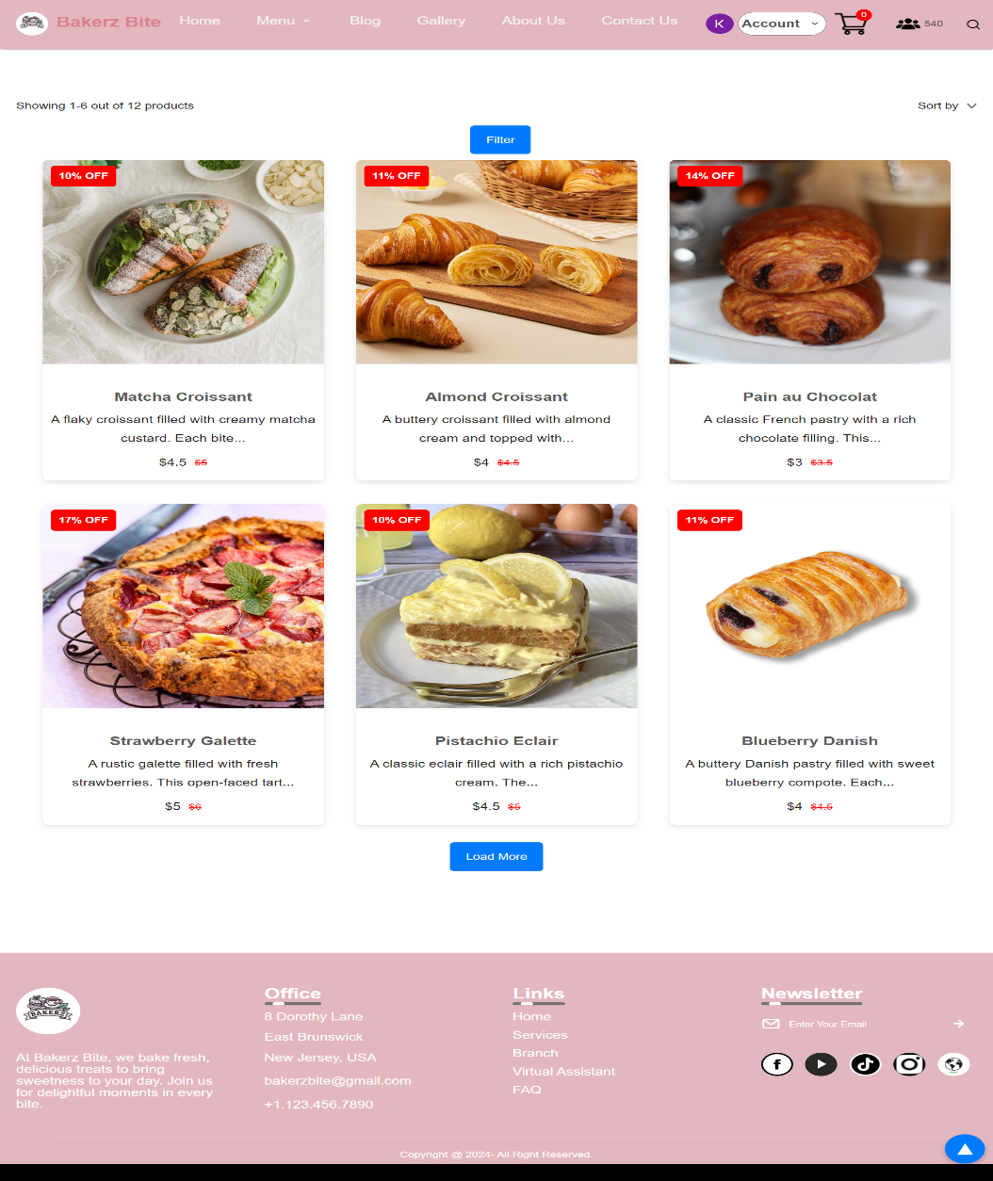

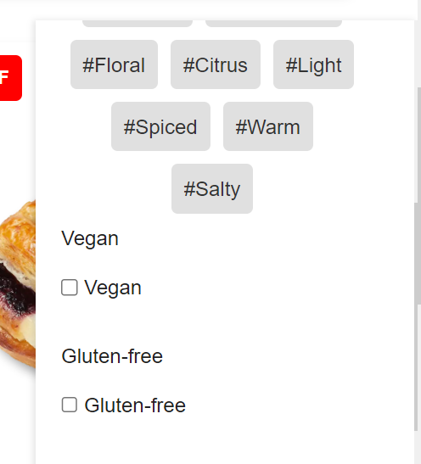

Currently, the store is updating 100 products for you to choose from. This is also a commitment to building a bakery website with diverse offerings to meet every customer's needs.

**IV-Product Display Page**

On the **Product Display** page, customers can view detailed information about the product and proceed to purchase it. Customers can select the cake size they wish to buy and specify the quantity. There are two ways to purchase the product: clicking **Add to Cart** will update the shopping cart with the selected item, or clicking **Buy Now** will take the customer directly to the payment page to complete the purchase. The number of items will be updated directly on the Cart Icon in the navbar, allowing customers to know how many products they are currently buying.

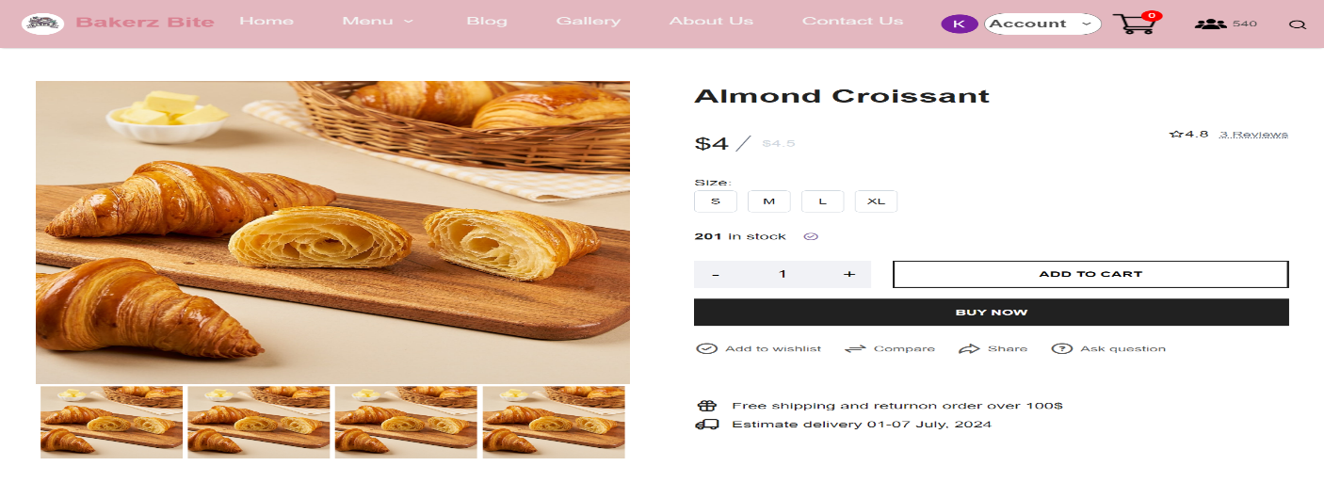

On the **Product Display** page, you have several functionalities to enhance your shopping experience:

**4.1. Add to wishlist**

You can add the product to your wishlist by clicking the **Add to wishlist** button. This allows you to save products you like for future reference.



**How to Access**: To view your wishlist, click on your account on the navigation bar. A drop-down menu will appear. Select **My Cake** to see the products you've added to your wishlist.

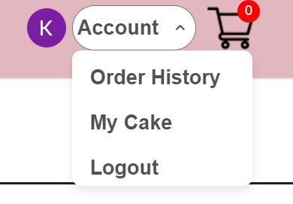

**Persistent Storage**: Products added to your wishlist will remain there even after you leave the site. They will be saved and available for you upon your next visit.  
 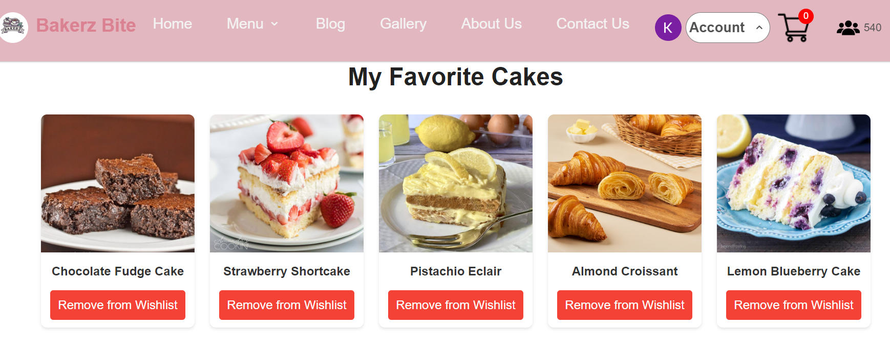  
**Removing Items**: If you want to remove a product from your wishlist, simply click the **Remove from Wishlist** button. The product will be deleted from your saved list.

**4.2. Compare**

The Compare feature allows you to compare different products to help you make an informed decision about your purchase. By clicking on the **Compare** button, you will be able to view a comparison chart.  
 

**Comparison Chart**: This chart displays a side-by-side comparison of the product you are currently viewing with other products from the same category. The comparison includes product name, image, description, ingredients, and price.

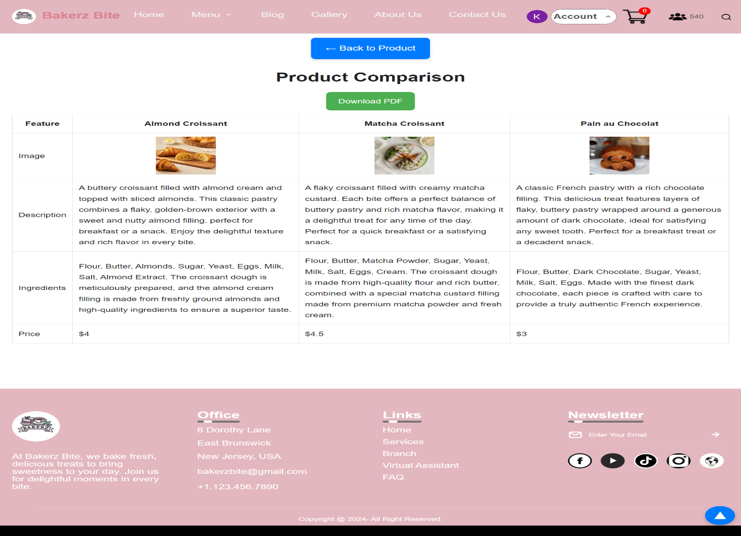

**Adding Products to Compare**: If you wish to compare different products, simply click on the product image or title from the comparison chart. This will bring up a selection of other products from the same category for you to choose from.

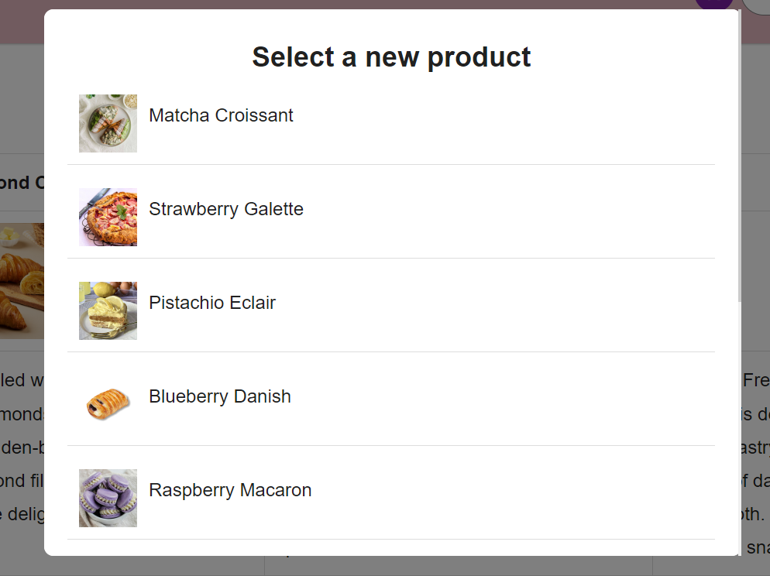

**Returning to Product Display**: Once you have made your decision, you can click the **Back to Product** button to return to the **Product Display** page.

**Exporting Comparison**: An additional feature allows you to download the comparison chart as a PDF file, so you can save it to your device for future reference by clicking **Download PDF**.

**4.3. Share**

If you want to share a product with your friends and family, the **Share** feature makes it easy. Simply click the **Share** button to reveal a link to the product, along with options to share it on various social media platforms such as Facebook, Google, and other networks depending on what you use.



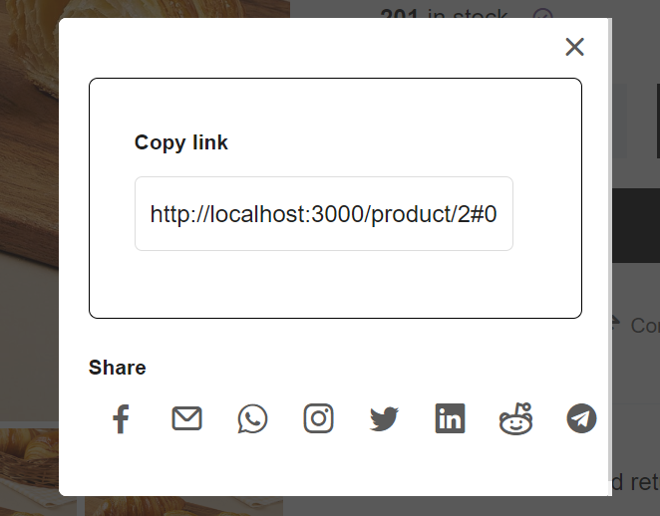

For example, you can share the product via X social network to let your friends know about it.

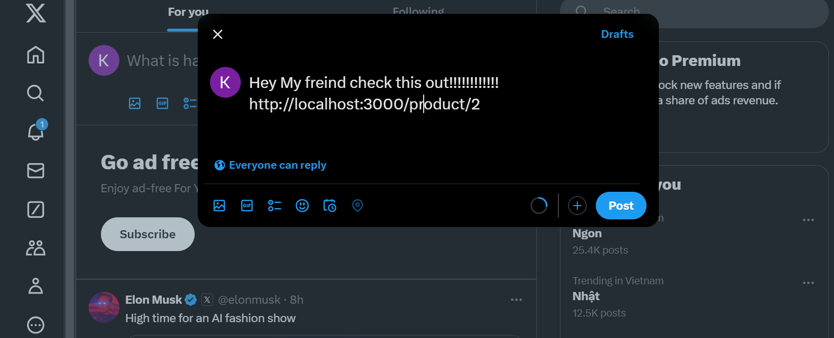

**4.4. Product Information**

You can view detailed product information right here.This includes:

* **Description**: An introduction to the product, outlining its key features and what makes it special.  
  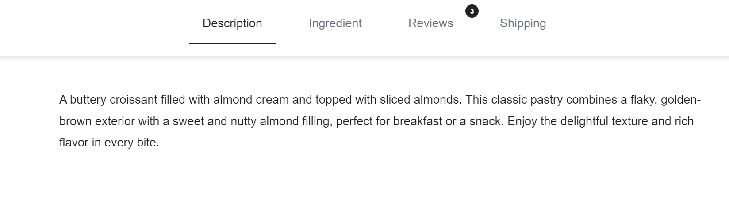
* **Ingredients**: A list of ingredients used to create the product, so you know exactly what’s inside.  
  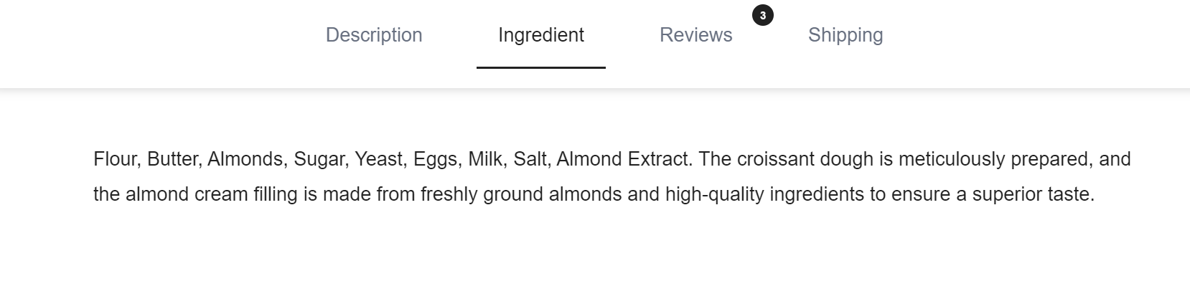
* **Customer Reviews**: Read feedback and ratings from other customers to get a sense of their experiences and satisfaction.

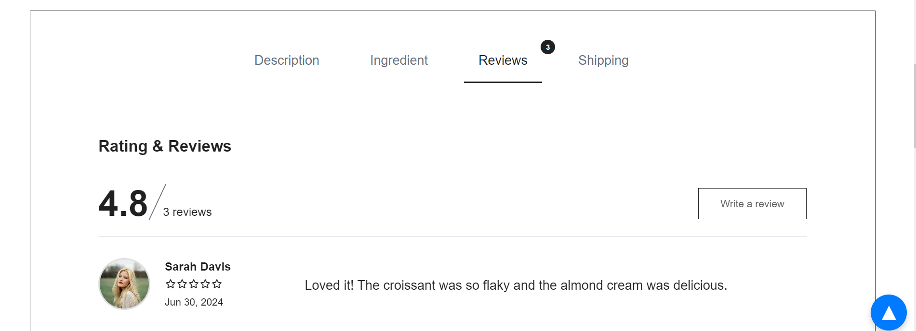

In the Reviews section, you have the opportunity to share your own thoughts and feedback about the product. Here's how you can leave a review:

* **Write a Review**: Click on the **Write a review** button to open the review form.



* **Review Form**:
  + **Name**: Enter your name.
  + **Email**: Provide your email address.
  + **Rating**: Rate the product by selecting the number of stars (1 to 5) that reflect your satisfaction.
  + **Review Content**: Write your detailed review or comments about the product.
  + **Upload Photo**: Optionally, you can upload a photo of the product or your experience to accompany your review.

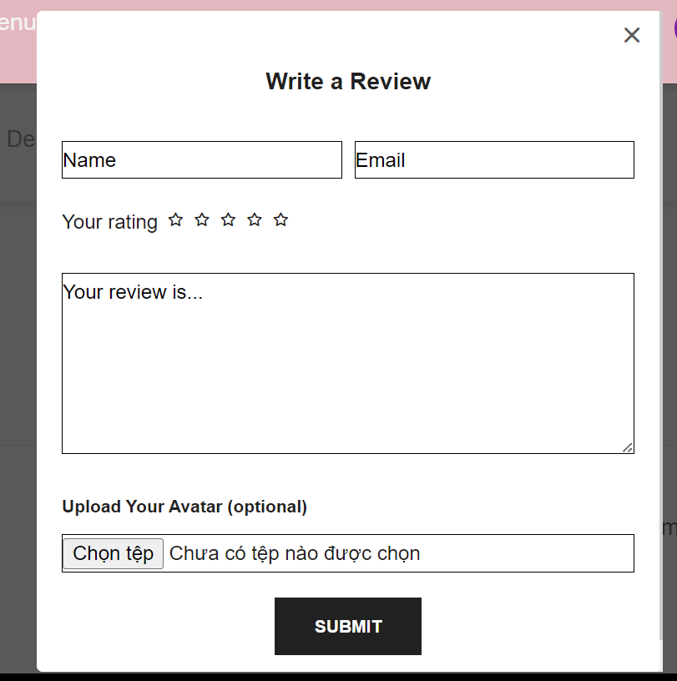

After filling out the review form, click on the **Submit** button. Your review will then be added to the product page and will be visible to other customers.

This feature allows you to contribute to the product's community feedback and helps other customers make informed decisions. All submitted reviews will appear on our website, showcasing real customer experiences and opinions.

Here's an example of a review:

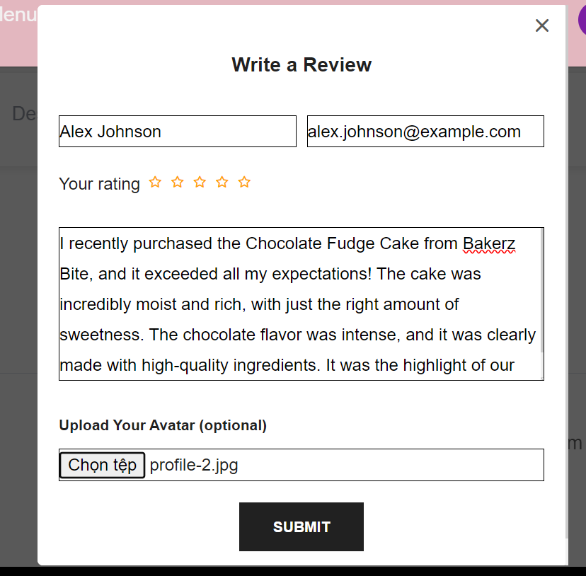

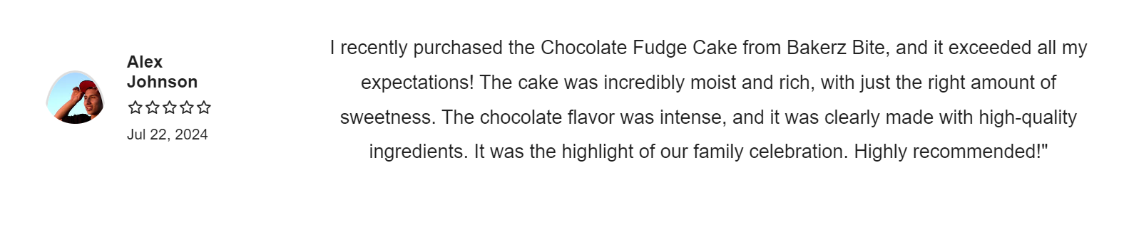

* **Shipping Information**: Details about the shipping methods available, delivery times, and any other relevant information.

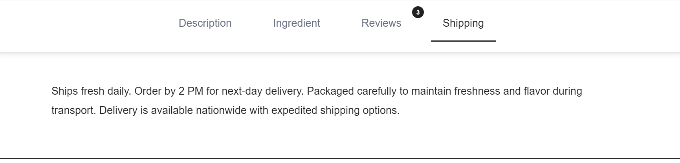

With a catalog of 100 products, each product's information is unique to ensure that you receive specific and relevant details without any duplicate content, except for general shipping information.

**4.5. Related Products**

In this section, you'll find other items that belong to the same category as the product you're currently viewing. This feature allows you to explore similar products without having to navigate back to the main product page.

* **Navigation Arrows:** Click the left or right arrows to cycle through related products. This allows you to view different options within the same category quickly.
* **Drag and Drop:** Hold and drag the image of a product to move. This feature makes it convenient to explore related products.

When you select a product from a category, the **Related Products** section will automatically update to display all available items within that category. This ensures that you have easy access to all relevant options and can make an informed decision about your purchase.

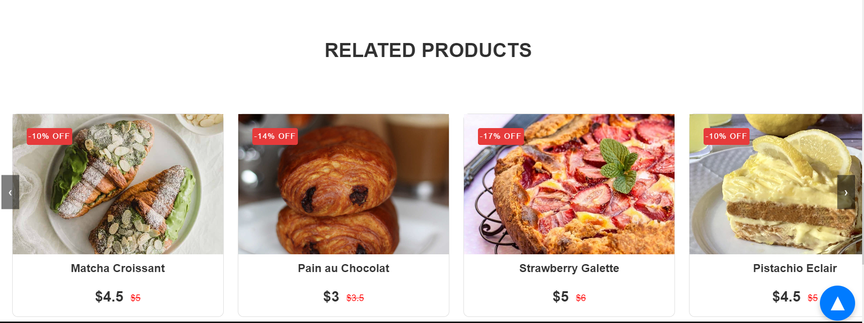

**4.6. Add to cart**

Once you've selected the products you wish to purchase, you can add them to your cart by clicking the **ADD TO CART** button. This action updates your shopping cart with the chosen items and their quantities.



**Updating Cart:** When you click **ADD TO CART** the selected quantity of the product will be added to your cart. The cart icon in the navbar will automatically update to reflect the number of items you've selected.

**Example:**

Suppose you've chosen to buy 3 cakes. You would select the quantity as 3.



Once you click the button, the cart will be updated to show that 3 cakes have been added.

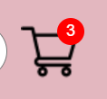

By clicking the **ADD TO CART** button, you ensure that your chosen products and quantities are accurately recorded in your shopping cart, making it easier to proceed to checkout and complete your purchase.

**4.7. Buy Now**

In addition to the ADD TO CART button, you also have the option to click **BUY NOW**. This button is designed to streamline your purchasing process by taking you directly to the **Payment** page, bypassing the **Cart** page.



**4.8. User Page**

The **User** page is only displayed when customers have logged in or registered an account. This page will show the customer's account information, update their reward points, and display the history of points earned and used.

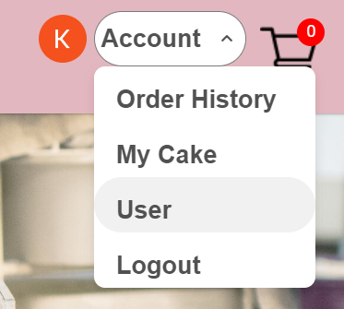

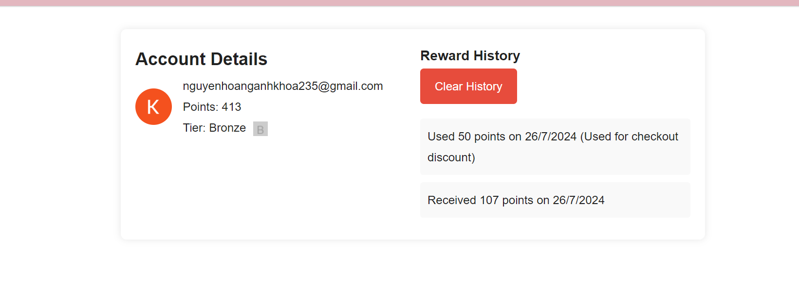

Customers can clear their points history by clicking the **Clear History** button. A confirmation message will appear, asking if the customer is sure they want to delete the history. If they click **OK** the history will be completely erased.

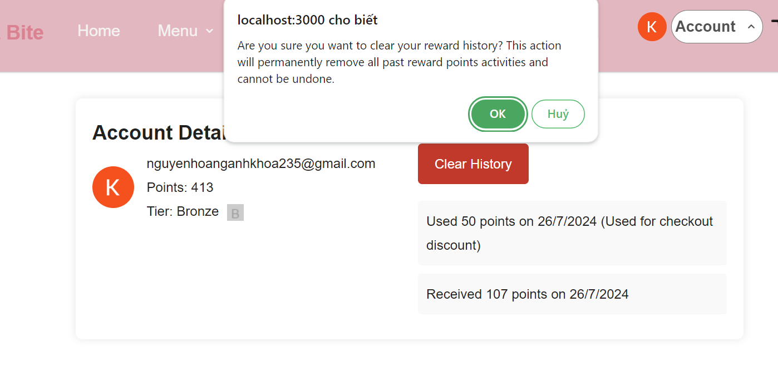

Additionally, customers can view their tier status based on the total reward points they have accumulated.

**V-Cart Page**

Here users will see detailed information about the added product, including:

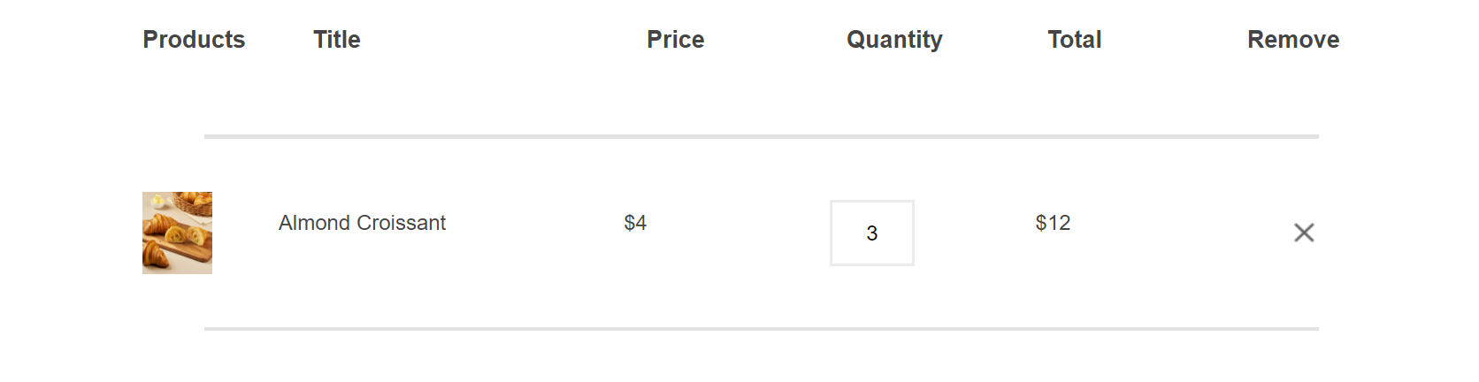

• **Product Image**: Allows users to easily identify the selected item.

• **Product Name**: Provides the full name of the product to ensure users know exactly what they have selected.

• **Product Price**: Shows the price of each item, helping users keep track of their expenses.

• **Quantity**: Enables users to adjust the number of items they want to purchase directly from the cart.

• **Total Price**: Calculates the total cost for the selected quantity of each item, giving users a clear understanding of the total amount to be paid.

Customers can also increase or decrease the quantity of products they purchase in the quantity section.

Scrolling down, users will find the **Cart Total** section, which includes:

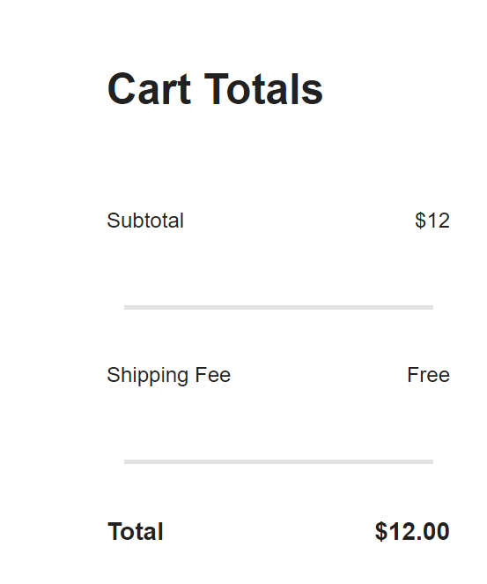

* **Subtotal**: The total cost of all items in the cart before applying any discounts or shipping fees.
* **Shipping**: Displays the shipping fee, and if the order qualifies for free shipping, it will show Free.
* **Total Payment**: The final amount that users need to pay, including shipping fees and any discounts applied.

On the right side of the **Cart Total** section, there is a box to apply a promotional code if available. Users can enter their promo code here to receive a discount on the total payment. Additionally, customers can use their accumulated reward points to redeem for cash value, further reducing the total payment.

**5.1. Discount coupon**

When a user purchases products on the Bakerz Bite website, they will receive discount coupons based on the total amount spent. The specifics of the discount scenarios are as follows:

* **$20+ Purchase Discount**: If the total price of the items in the cart is $20 or more, users will receive a discount coupon code. Users need to copy this code and paste it into the promo code box, and the discount will be activated immediately. They will see the discount amount reflected in the **Cart Total** section.

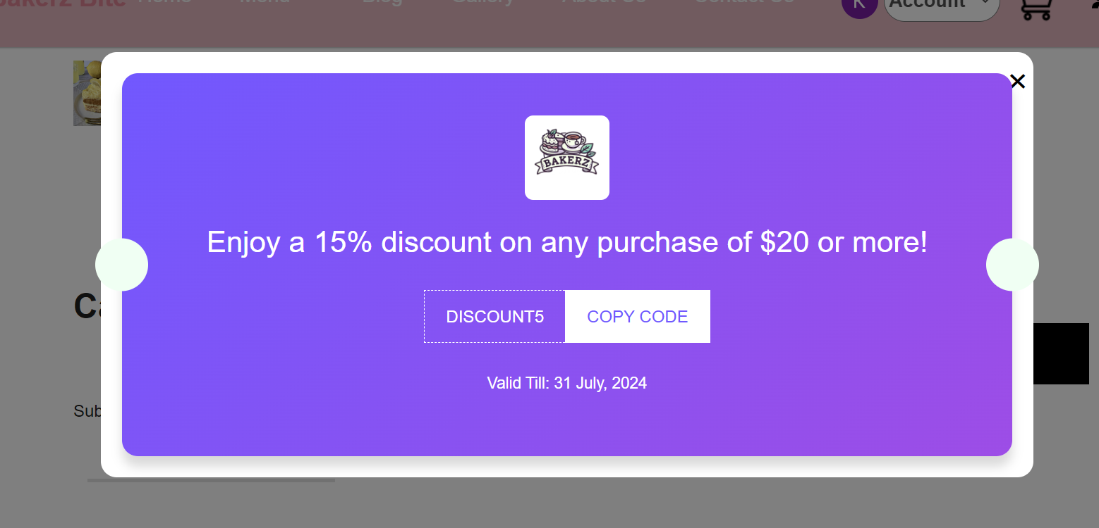

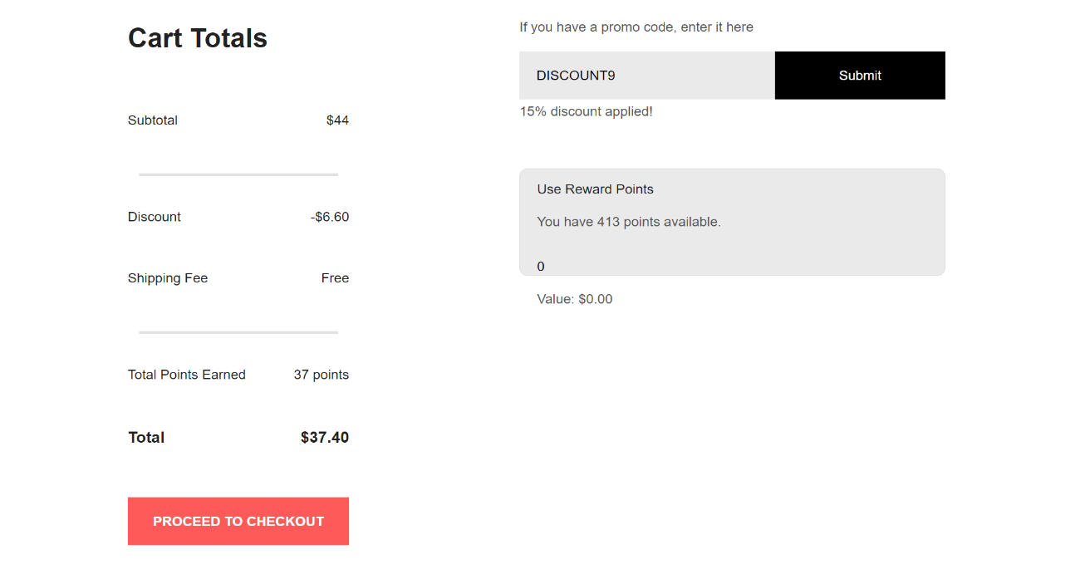

* **$50+ Purchase 20% Discount**: If the total price of the items in the cart is $50 or more, users will receive a coupon code for a 20% discount.

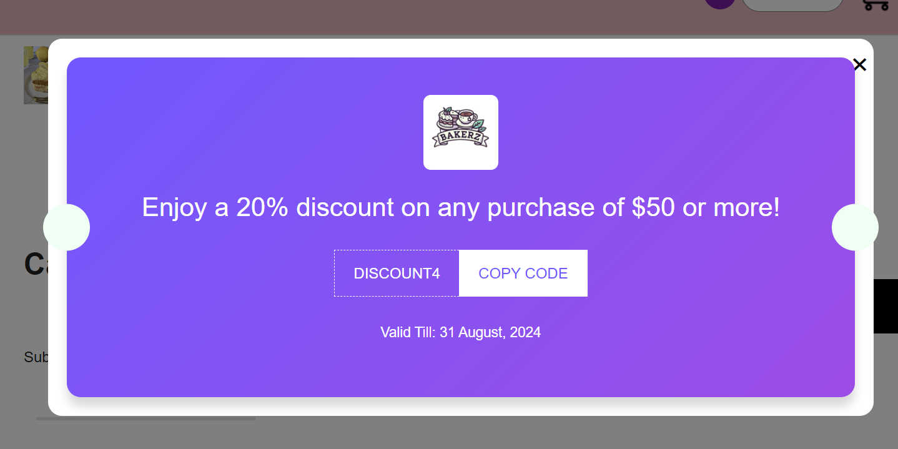

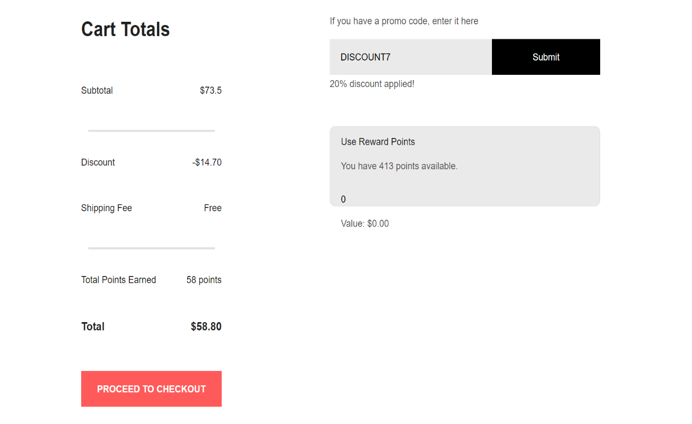

**5.2. Reward Point**

When customers purchase products at Bakerz Bite, they earn reward points. The principle is as follows: for every 1 USD spent, 1 reward point is earned. Customers can use these reward points to redeem for cash value, for every 100 points 1 USD is deducted from the total. There will be a display box showing the number of points the customer currently has. Customers can select the number of points they wish to redeem, and the discounted amount will be displayed below.

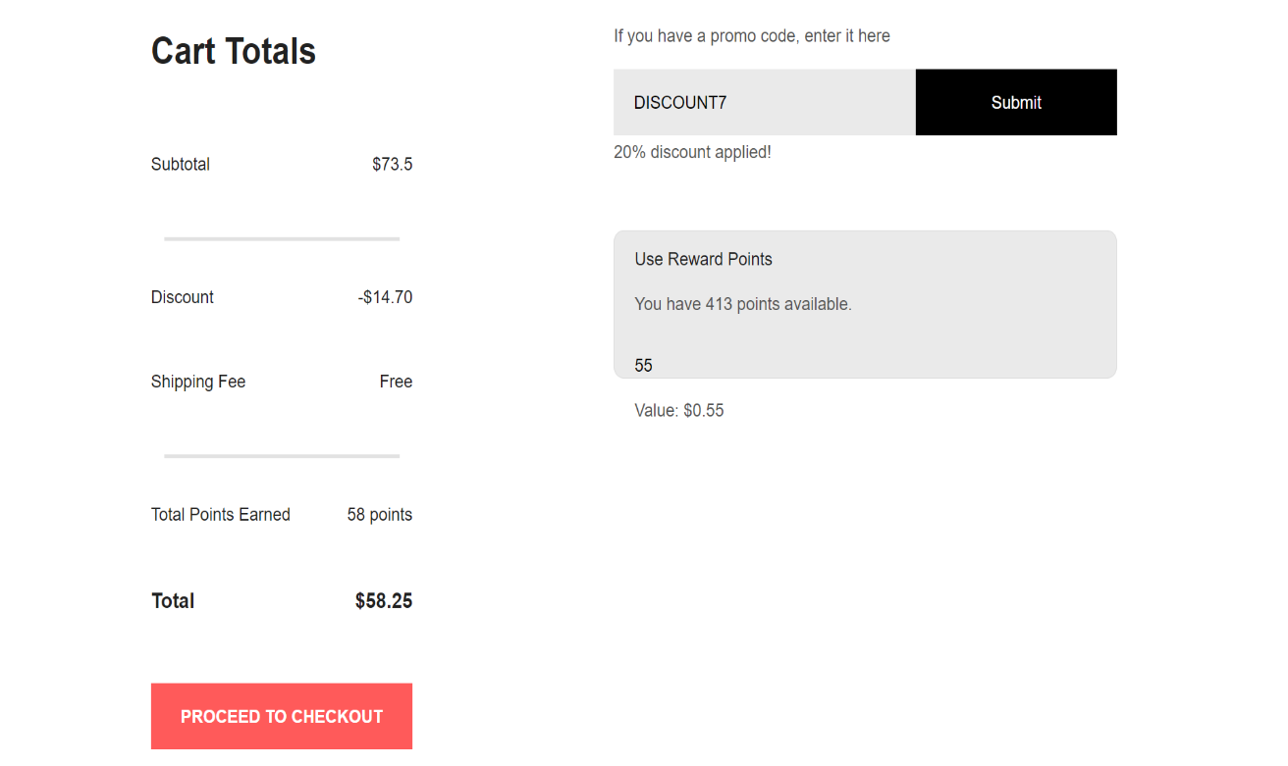

After that click **PROCEED TO CHECKOUT** button move to **Payment** page.

**VI-Payment Page**

**6.1. Form**

On the Bakerz Bite website's Payment page, users will see a form on the left side that requires them to fill in the following details:

* **Shipping Address**: Users need to provide their shipping address, including details such as street address, city, state, postal code, and country.

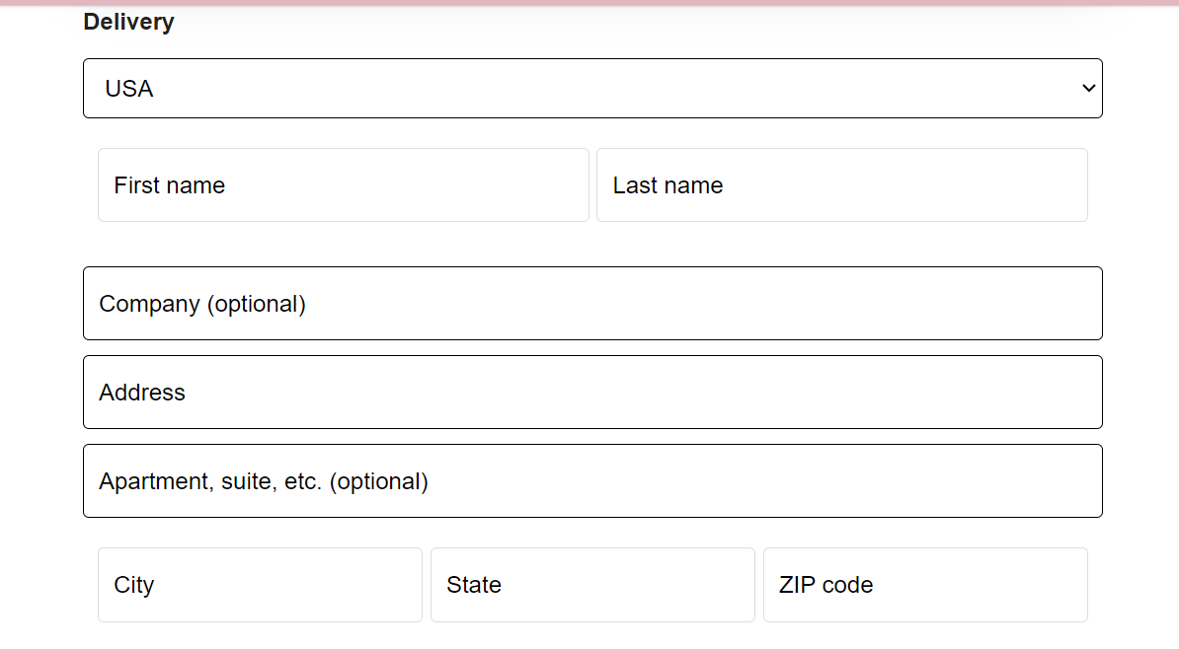

* **Payment Information**: This section includes fields for entering payment details, such as credit card number, expiration date, and cardholder name.

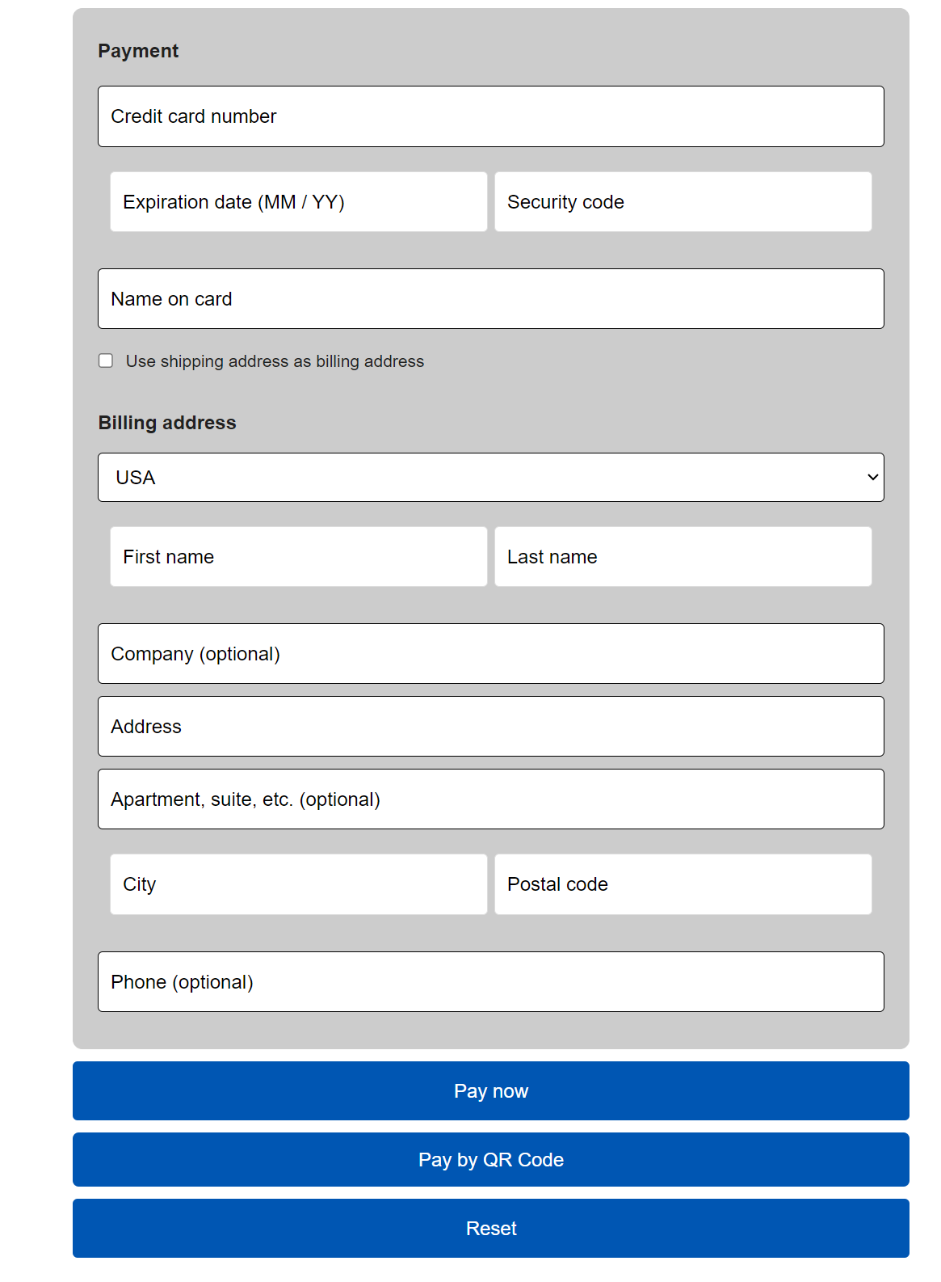

On the right side of the Payment page is the **Order Summary** section, which displays:

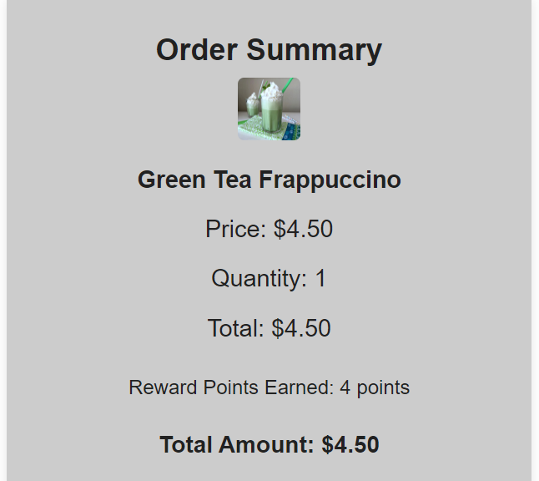

* **Product Image:** Visual representation of the item(s) being purchased.
* **Product Name:** Full name of each product in the order.
* **Quantity:** Number of units of each product ordered.
* **Total:** Price of each product.
* **Discount:** Any applicable discounts are shown here if a promo code was applied.
* **Reward Points Earned:** The number of reward points the customer earns from the purchase.
* **Total Amount:** The final amount to be paid, including all discounts and shipping fees.

After entering all the required information, users can click the **Pay now** button to complete their purchase. If the order is successfully placed, a notification saying **Order placed successfully** will appear, confirming that the transaction was completed.

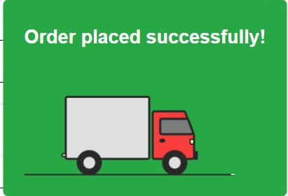

Additionally, users have the option to pay by QR code. By selecting the **Pay by QR Code** button, a pop-up window will appear containing:

* **QR Code**: For users to scan with their mobile device.
* **Store's Bank Account Information**: Details needed for completing the payment via bank transfer.

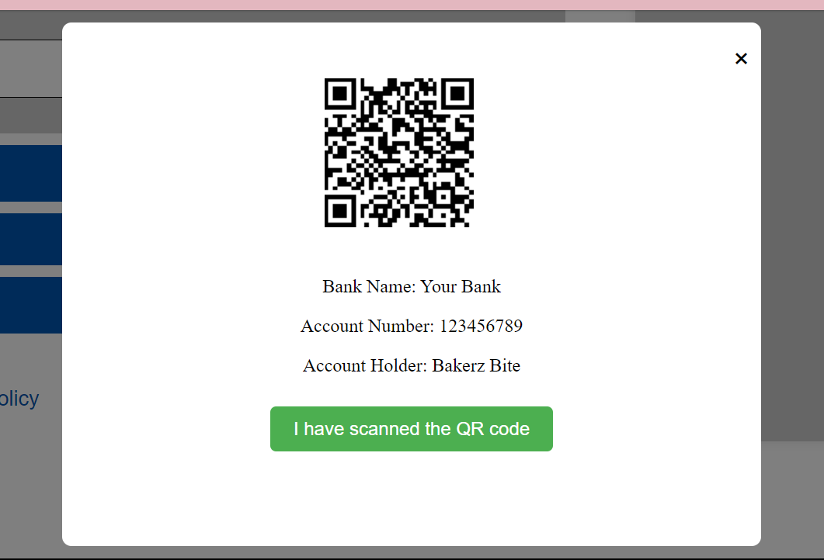

After scanning the QR code, users need to click the **I have scanned the QR code** button to confirm the payment.

If the QR code payment is successful, a notification saying **Order placed successfully** will appear.

**6.2. Policy**

By clicking on the respective links, you can view detailed information on each policy:

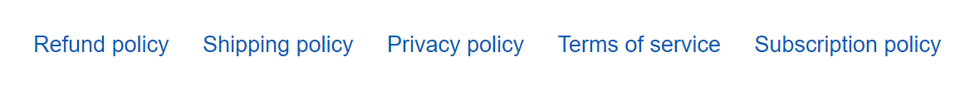

* **Refund Policy**: Learn about our procedures for returns and refunds, including the conditions under which a refund is applicable and how to initiate the process.
* **Shipping Policy**: Find out about our shipping methods, delivery times, and any associated costs to ensure your order reaches you promptly and efficiently.
* **Privacy Policy**: Understand how we collect, use, and protect your personal information, and your rights concerning your data.
* **Terms of Service**: Familiarize yourself with the terms and conditions governing your use of our website and services.
* **Subscription Policy**: Get information about our subscription services, including how to subscribe, manage your subscription, and cancel if needed.

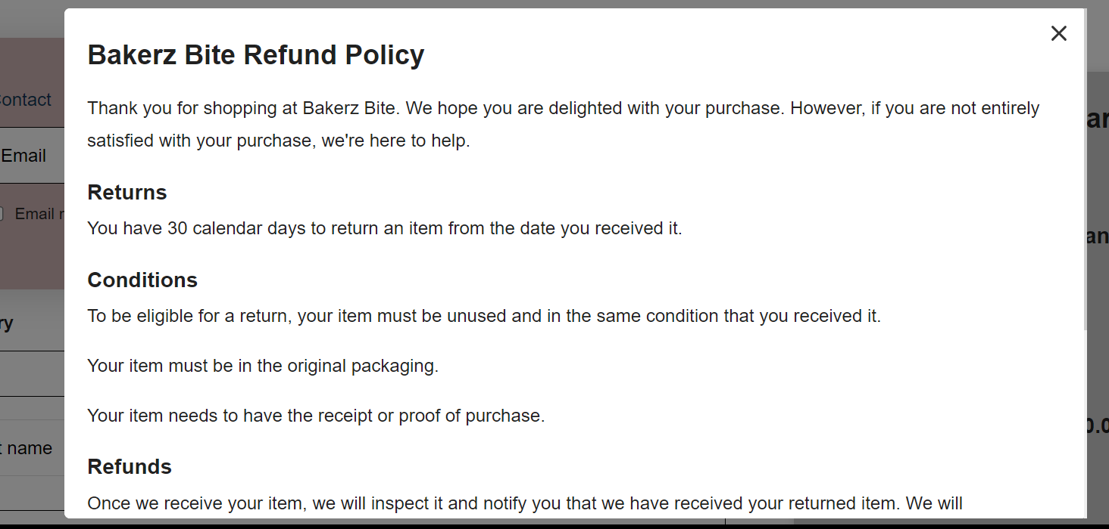

**VII-Blog Page**

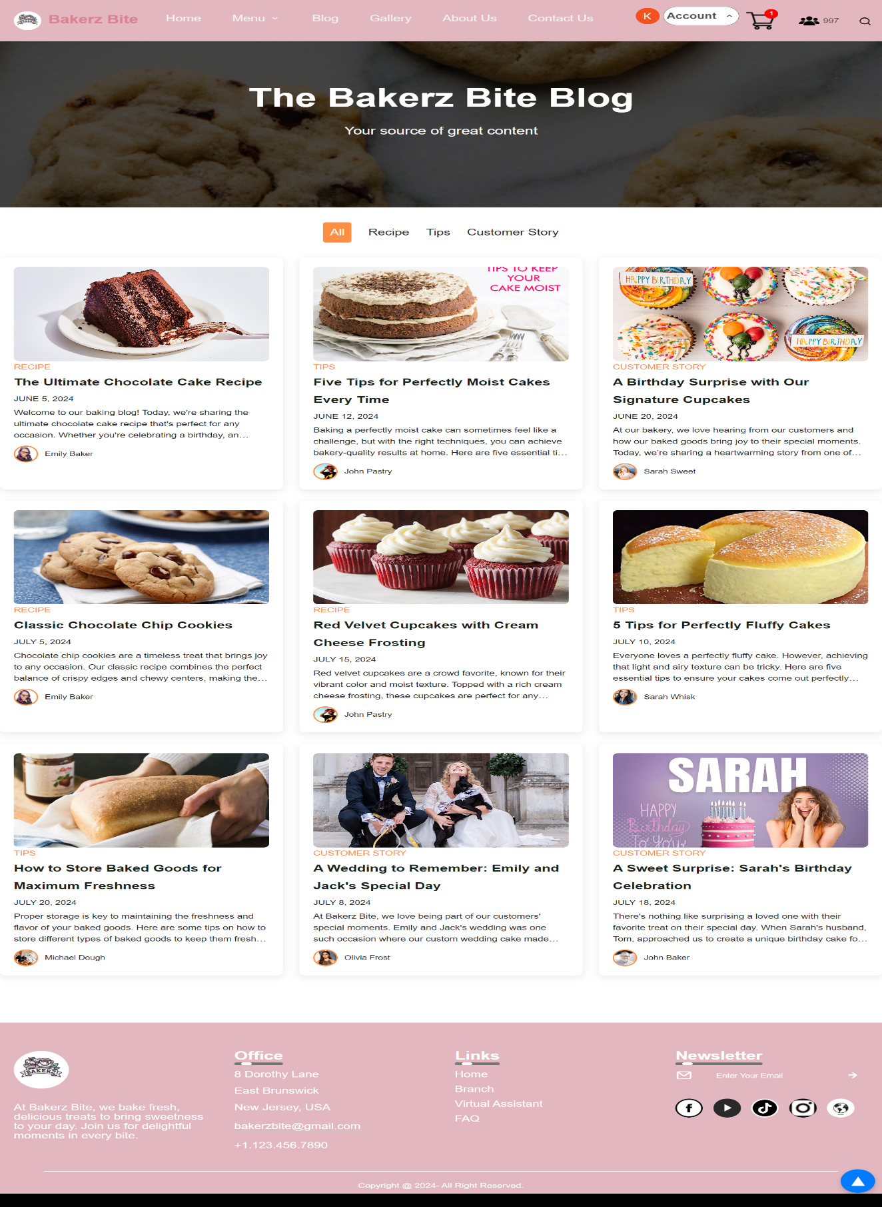

When users click on the **Blog** button on the navbar, they will be directed to the **Blog** page. At the top of the page, there are buttons labeled **All**, **Recipe**, **Tips**,and **Customer Story**. Clicking on the respective button will filter and display articles based on the chosen category.  


Each blog post will feature:

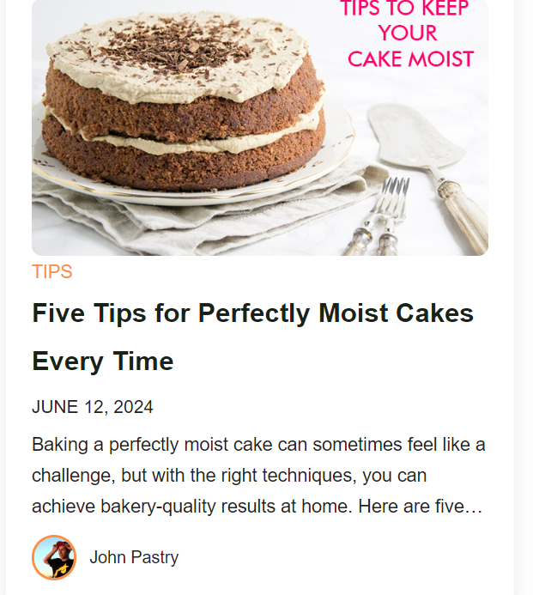

**Image**: A visual representation related to the article's content.

**Title**: The headline of the blog post.

**Excerpt**: A brief portion of the content to give readers an idea of what the article is about.

**Publication Date**: The date the article was published.

**Author Name**: The name of the person who wrote the article.

This setup allows users to easily navigate and find the information they are interested in, whether they are looking for new recipes, helpful tips, or inspiring customer stories.

**7.1. Detailed post page**

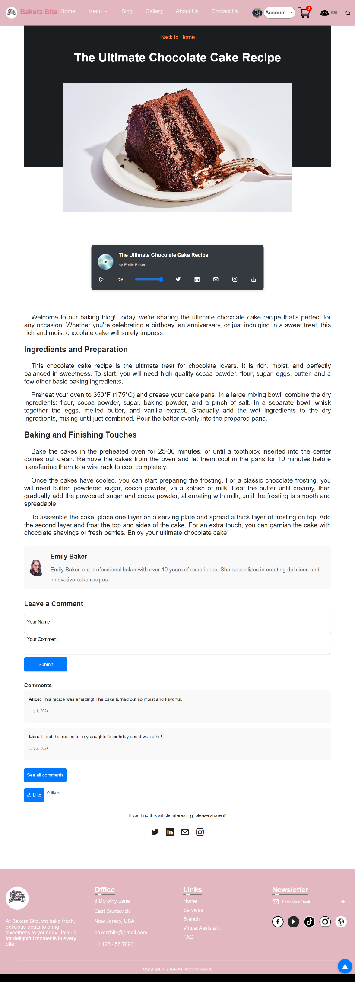

When users want to view the full content of a blog post, they simply need to click on the article, and they will be able to read the entire post. The articles are concise, focusing on the main content without being too lengthy.

Each post will also have subheadings to help users follow the structure and flow of the content.

This setup ensures that readers can easily access, read, and share the blog posts, making the content more engaging and accessible.

**7.2. File audio**

An audio version of the article will be available, which users can download to listen to later or share with friends. Sharing is made easy with social media icons for quick access.

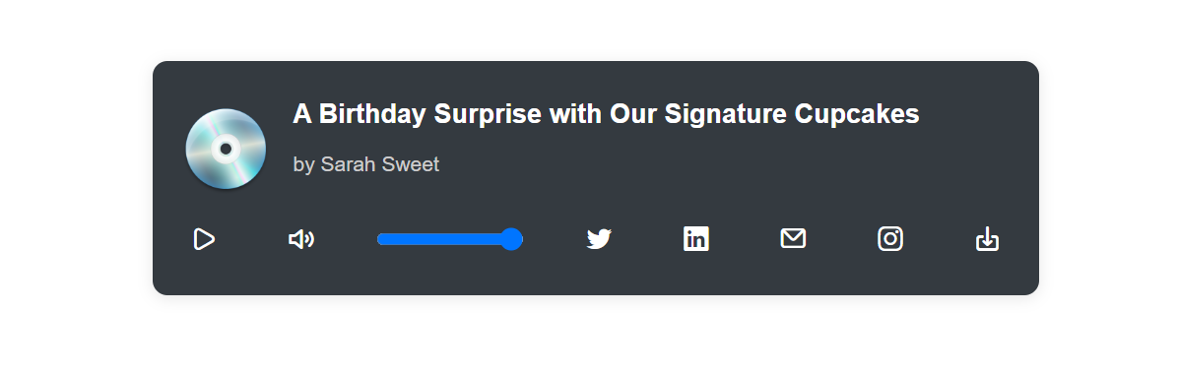

**7.3. Share and Write comments**

Beneath each blog post, you will find detailed information about the author along with a comment box, inviting you to share your thoughts.

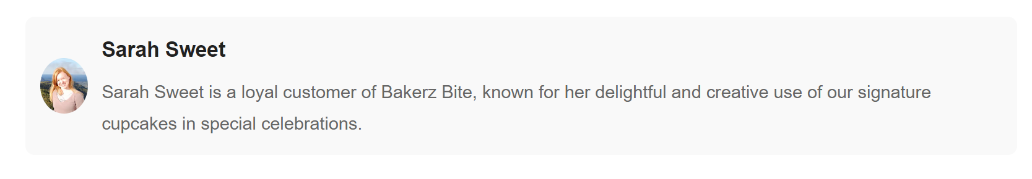

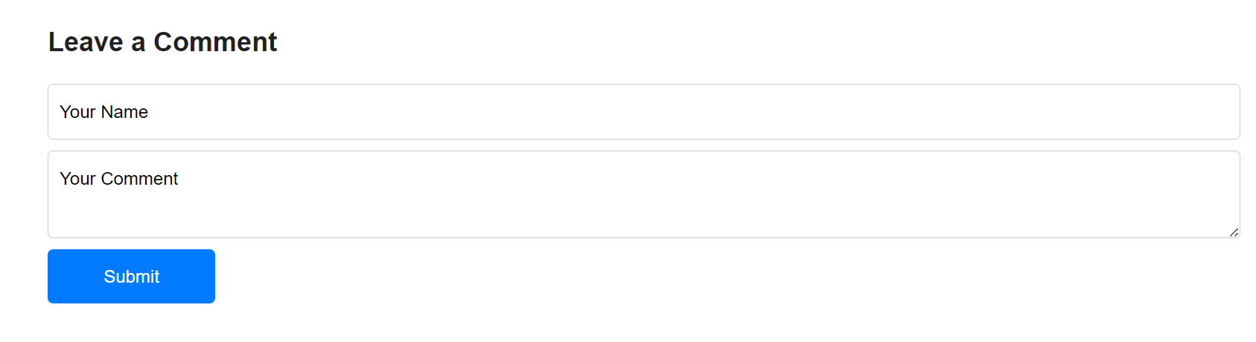

Your comments will be displayed in the **Comments** section. To view all comments, simply click **See all comments**.

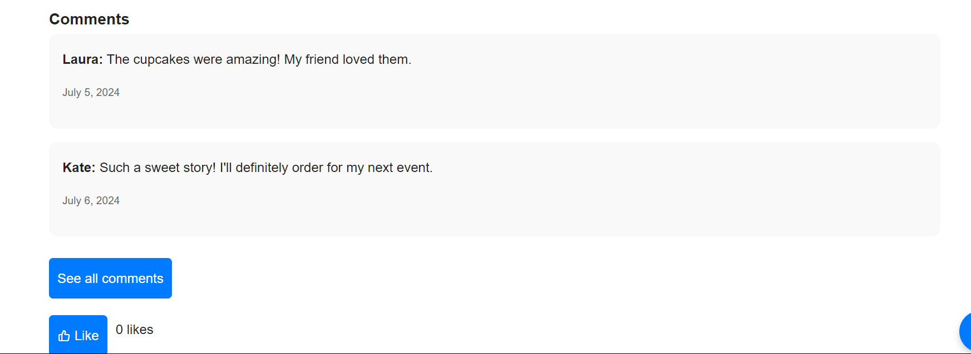

Here is an example:

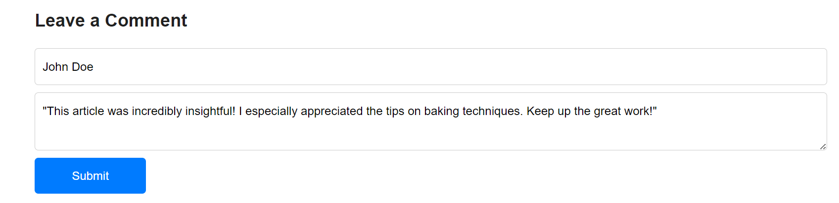

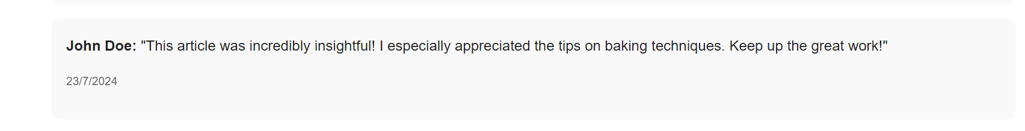

If you enjoyed the article, show your appreciation by giving the author a like.

If you found the post valuable, easily share it on social media by clicking the corresponding icons below.



For example I want to share this article for my friends on X social network:

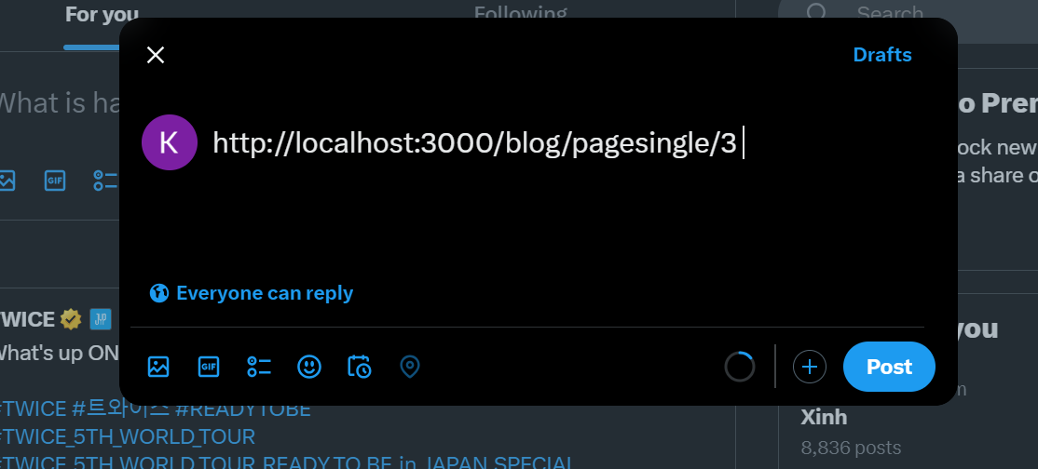

This intuitive setup ensures that readers can effortlessly access, read, comment on, and share blog posts, enhancing engagement and interaction within the community.

If you want to return to the blog page, you can click the **Back to Home** button to go back.

**VIII-Gallery Page**

The Gallery Page of the Bakerz Bite website serves as a comprehensive visual showcase of the bakery's diverse range of products. This page is designed to provide users with an intuitive and engaging experience, allowing them to explore and appreciate the various baked goods offered by Bakerz Bite.

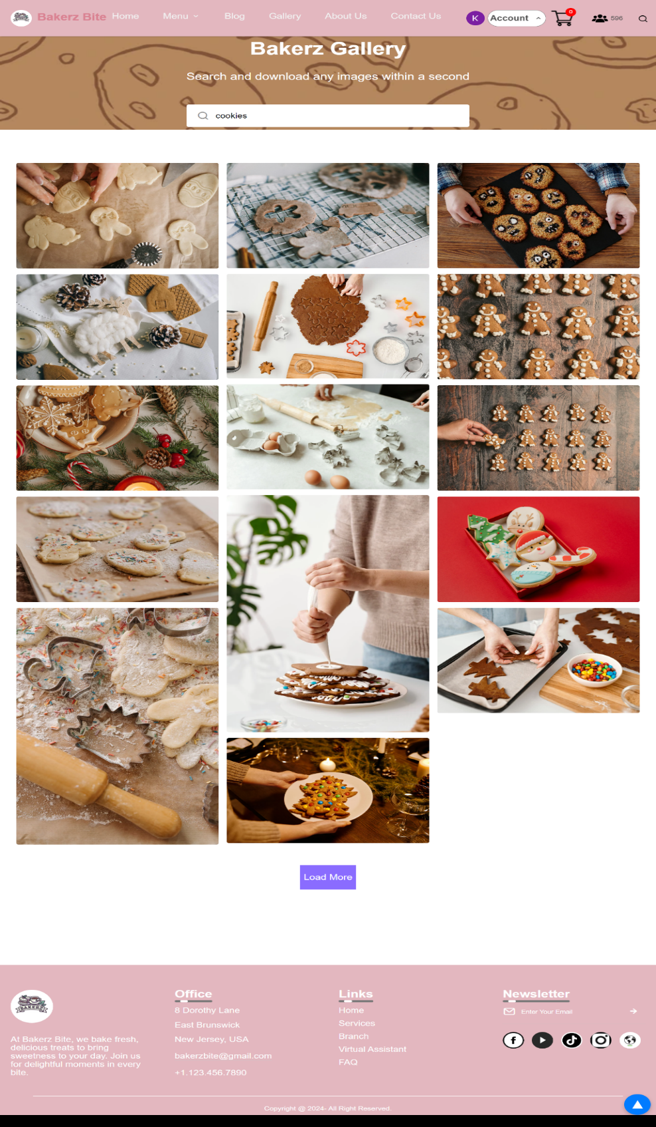

#### Features of the Gallery Page

**Comprehensive Image Collection**: The Gallery Page includes high-quality images of a wide variety of baked goods, including cakes, pastries, cookies, biscuits, and specialty breads. Each image is carefully selected to highlight the quality and craftsmanship of the bakery's products.

**Search Functionality**: To enhance user experience, the Gallery Page features a search bar that allows users to find specific types of baked goods. By entering keywords, users can filter the images to quickly locate items such as birthday cakes, gluten-free options, or seasonal specialties.

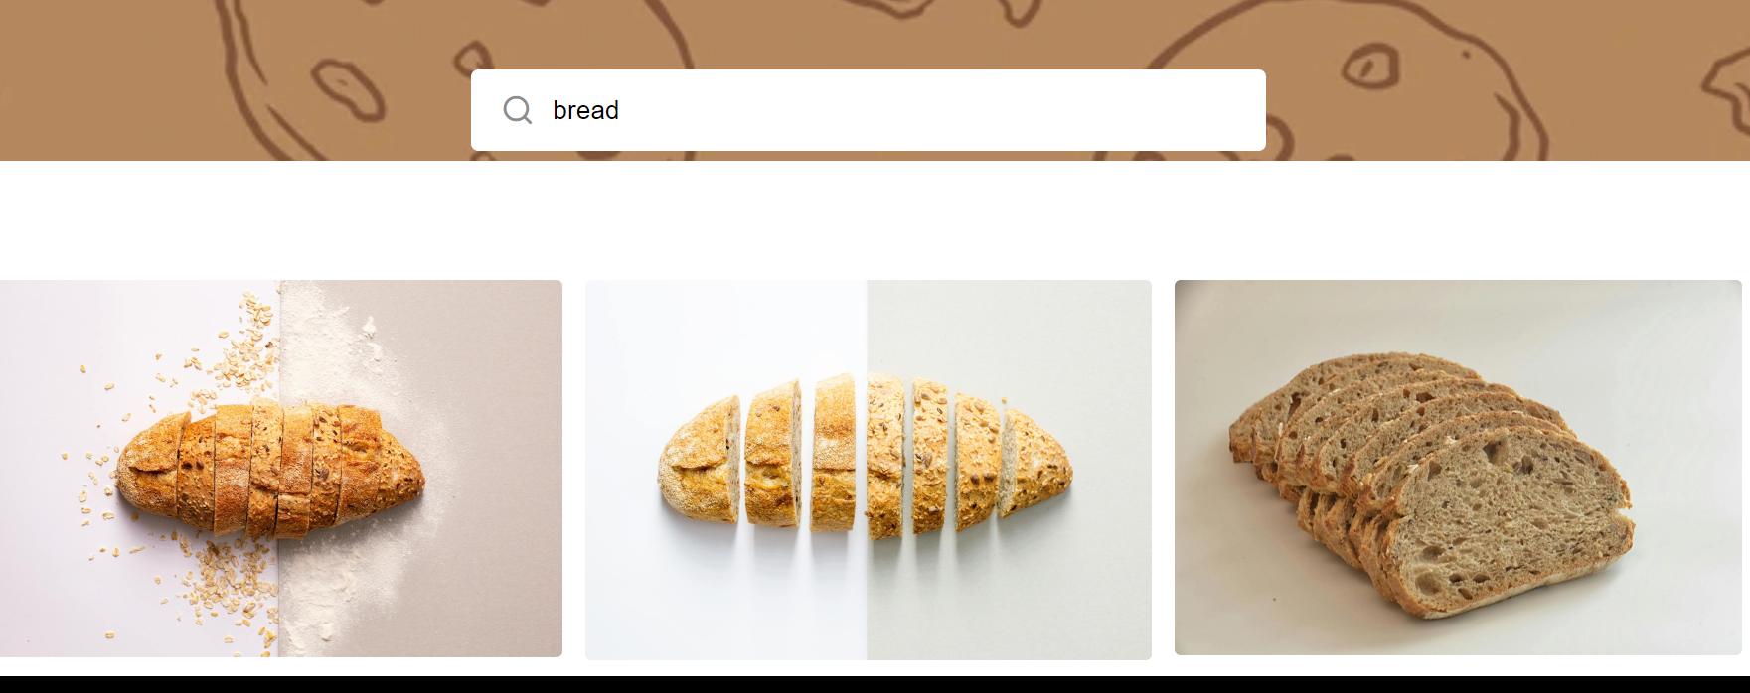

**Downloadable Images**: Users have the option to download images directly to their computer or mobile device. This functionality is particularly useful for those who wish to save images for future reference or share them with others.

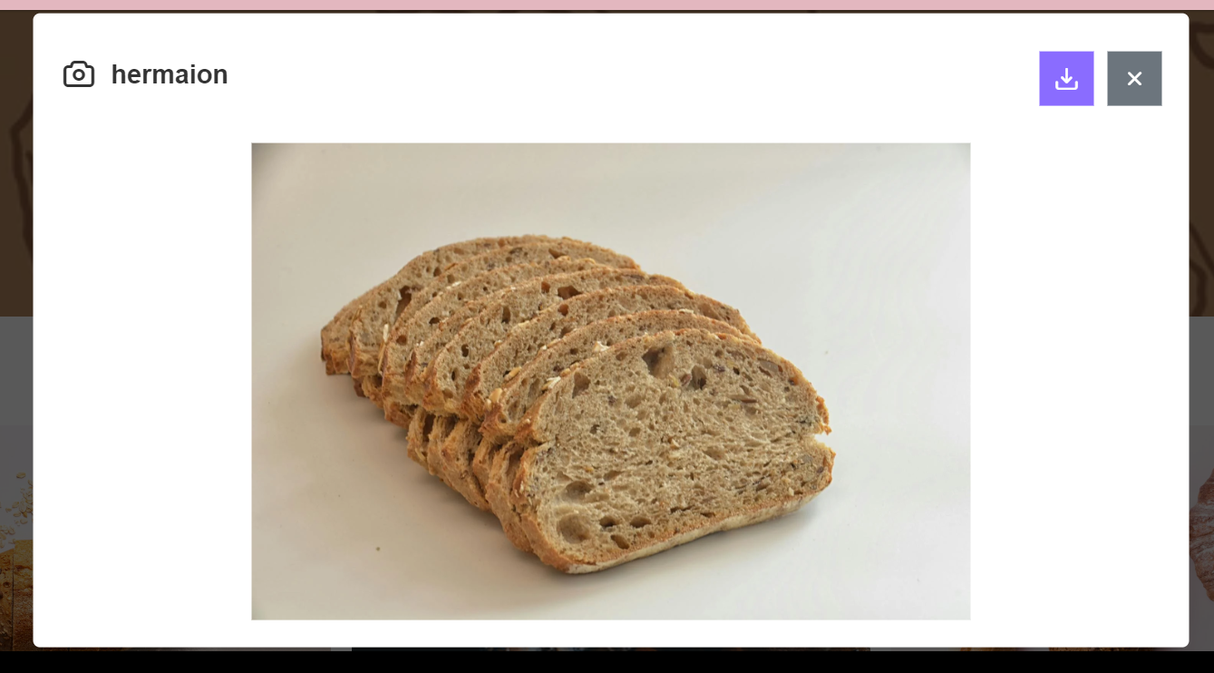

**IX- About Us Page**

The **About Us** page of the Bakerz Bite website is designed to provide users with comprehensive information about the bakery's background, mission, and values. This page plays a crucial role in establishing a connection with the customers by sharing the story and principles that drive the bakery. The **About Page** is structured into three main sections: Our Story, Our Mission, and Our Commitment.

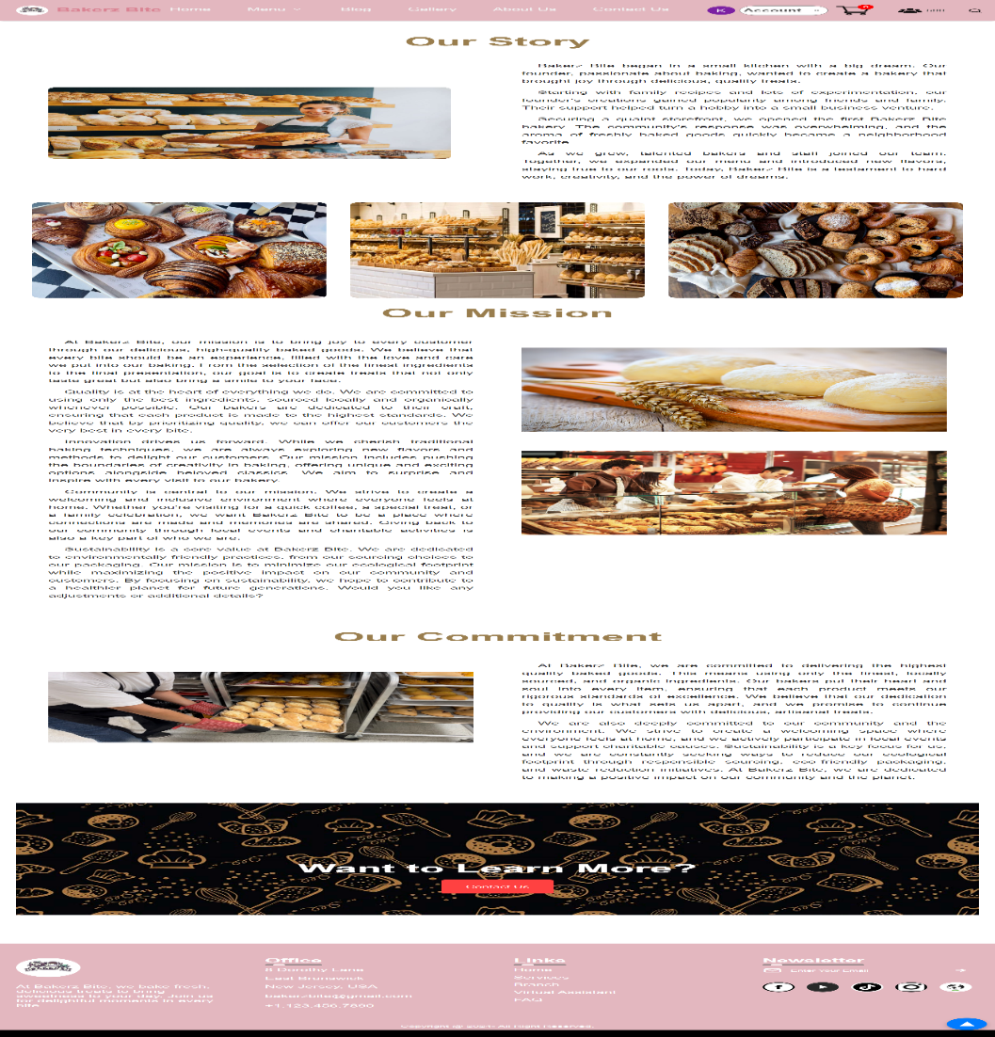

Overall, the About Page is a vital component of the Bakerz Bite website, providing valuable information that enhances user engagement and builds a strong brand identity.

**X-Contact Us Page**

The **Contact Us** page on the Bakerz Bite website is designed to facilitate easy communication between the bakery and its customers. This page provides comprehensive information and a user-friendly feedback form to ensure customers can effortlessly reach out to the store.

### Store Information

Upon visiting the Contact Us page, users are greeted with the essential contact details of Bakerz Bite, including:

* **Main Store Address:** 8 Dorothy Lane, East Brunswick, New Jersey, USA.
* **Phone Number:** +1 (123) 456-7890.
* **Contact Email:** [bakerzbite@gmail.com](mailto:bakerzbite@gmail.com)

These details ensure that customers have multiple ways to contact the bakery, whether by visiting in person, calling, or sending an email.

### Map for Directions

To assist customers in finding the bakery's location, the page includes an embedded map. This map not only shows the exact location of the store but also provides directions, making it easier for customers to navigate to Bakerz Bite.

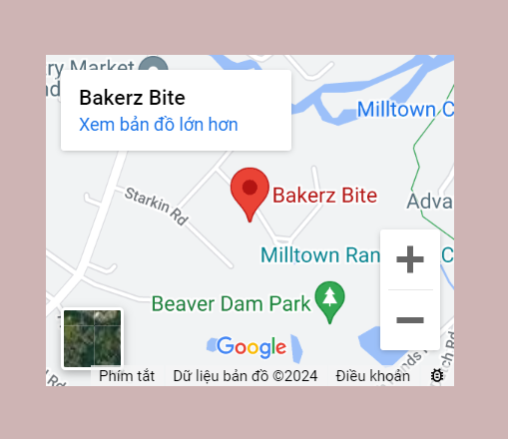

### Feedback Form

The **Contact Us** page features a feedback form that allows customers to leave their comments, suggestions, or inquiries. This form includes the following fields:

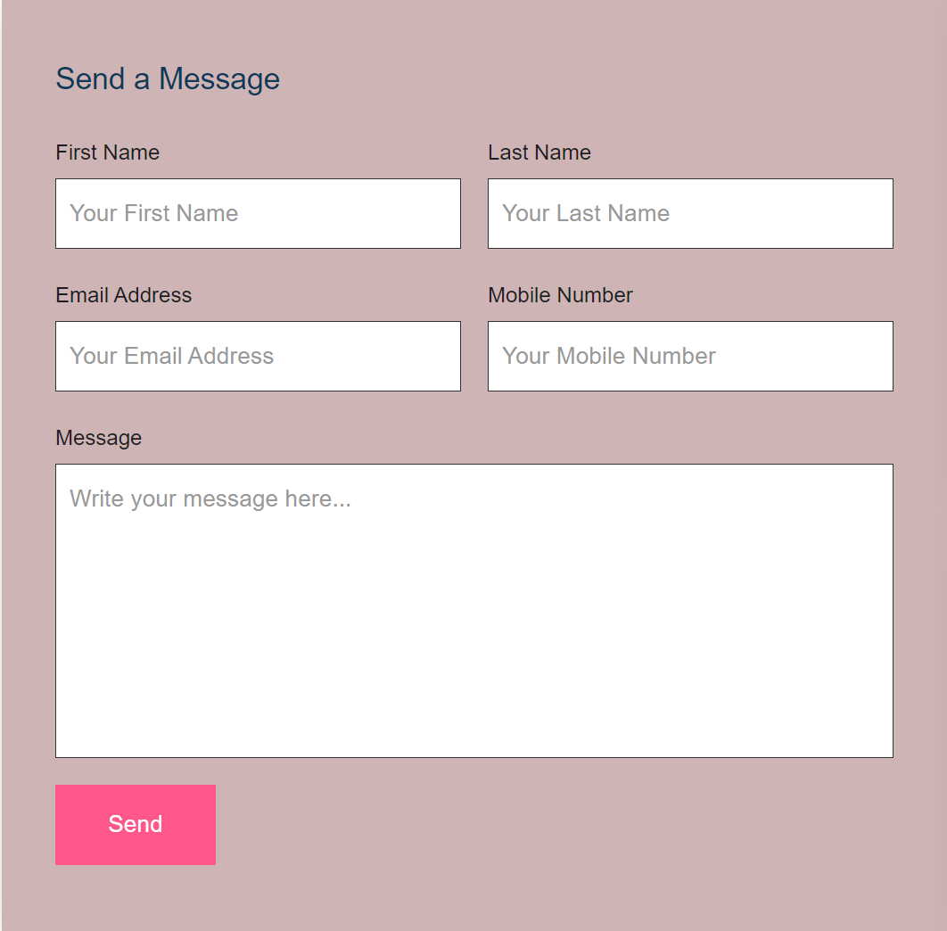

* **First Name:** A field for the customer to enter their first name.
* **Last Name:** A field for the customer to enter their last name.
* **Email:** A field for the customer's email address.
* **Mobile Number:** A field for the customer to provide their phone number.
* **Message:** A larger text box for the customer to write their message or feedback.

This form is designed to be straightforward and easy to complete, ensuring that customers can quickly share their thoughts or questions.

**Submit Button:**

At the bottom of the form, there is a **Send** button. When clicked, the customer will receive a notification confirming that their message has been sent successfully. This confirmation message assures the customer that their feedback has been received and that the bakery will respond as soon as possible.

Here is an example:

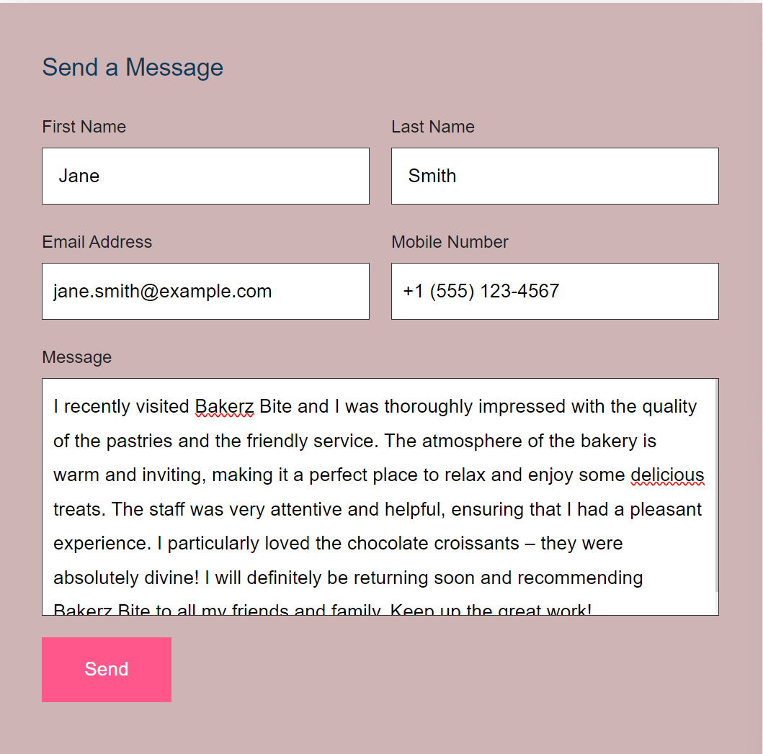

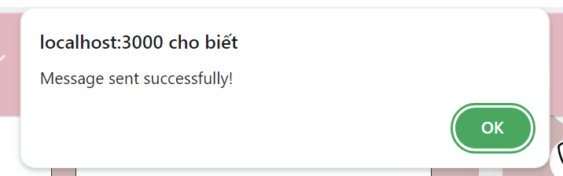

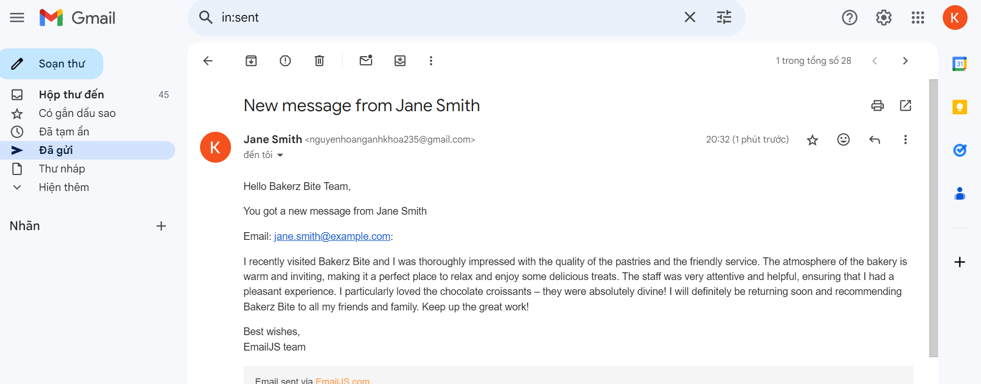

**XI-Login and Signup Page**

**11.1-Login**

The **Login** page on the Bakerz Bite website allows existing customers to easily access their accounts. This page includes a simple form for users to enter their email and password. It includes the following fields:

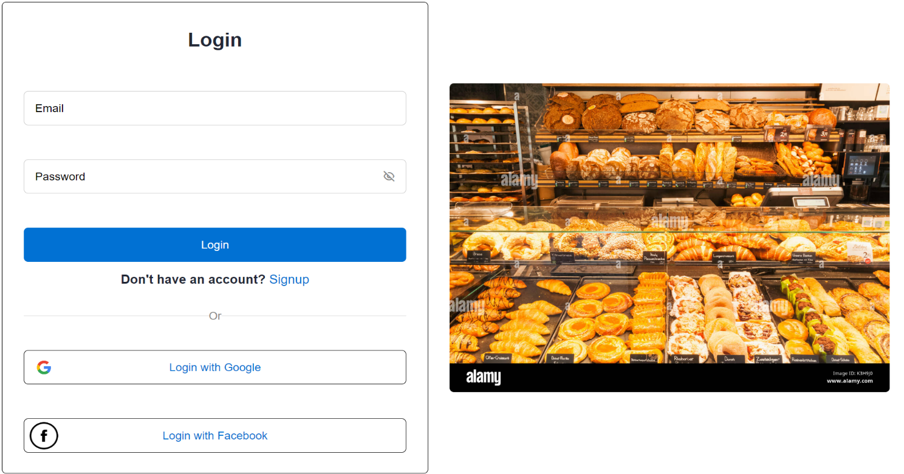

* **Email:** A field for the user to enter their email address.
* **Password:** A field for the user to enter their password.

### Alternative Login Option

For added convenience, the **Login** button also offers an option for customers to log in using their Gmail account. This allows for a quick and easy login process without the need to remember a separate password.



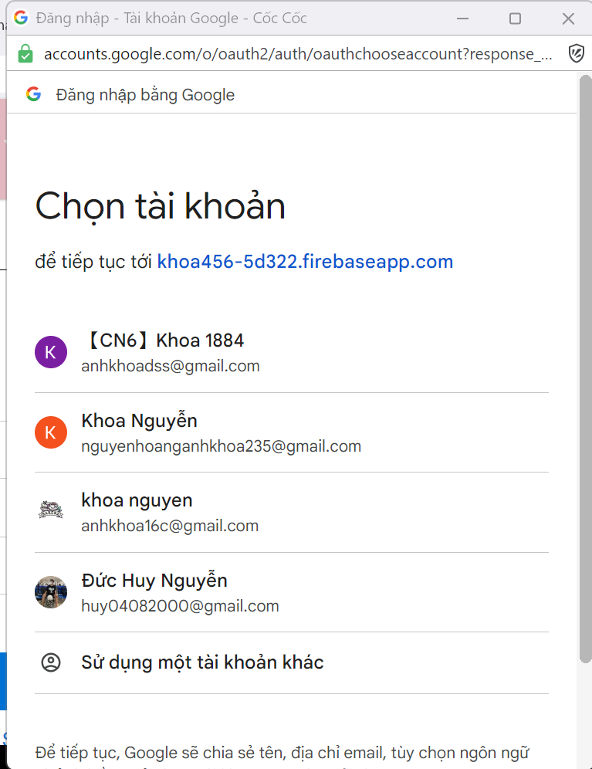

### Successful Login

Upon successfully login the customer's email avatar will appear on the navbar. This avatar serves as a visual confirmation that the user is logged in and allows for easy access to their account settings and personalized features.

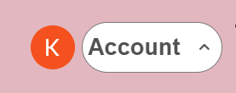

**11.2. Signup**

The **Signup** page on the Bakerz Bite website is designed to make account creation easy and straightforward for new customers. If you don't have an account yet, you can click on the **Sign Up** button to be directed to the sign-up page.

### Sign Up Form

Creating an account is simple and requires filling out the following fields:

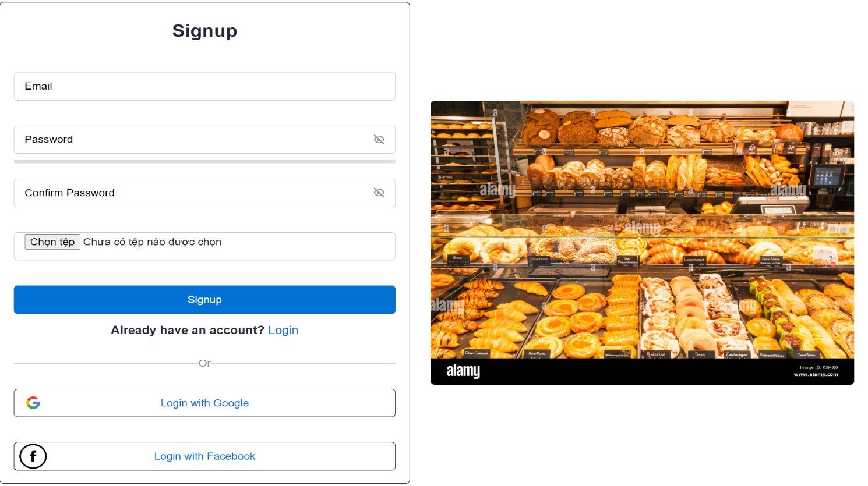

* **Email:** A field for the user to enter their email address.
* **Password:** A field for the user to enter a password.
* **Confirm Password:** A field for the user to confirm their password.
* **Avatar Upload**: A field that allows users to upload an image to set as their avatar.

The confirm password field includes password strength hints to help you create a strong password. A color bar indicates the strength of your password, ranging from weak to strong. Additionally, you can click on the eye icon to view the characters in your password, ensuring you've entered it correctly.

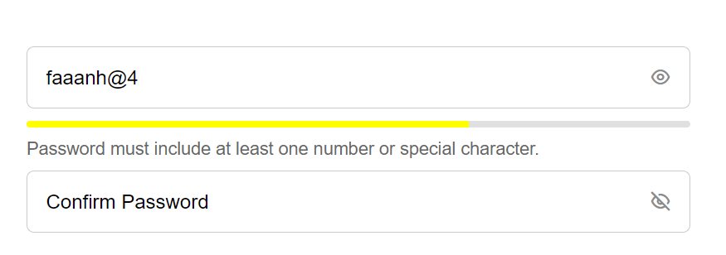

### Successful Account Creation

Once you've filled out all the information, click the **Sign Up** button to create your account. You will receive a confirmation message indicating that your account has been successfully created. You can then return to the login page and use your new credentials to log in.

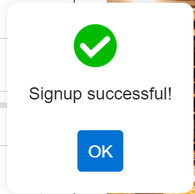

**XII-Footer**

The **Footer** section of the Bakerz Bite bakery website is designed to provide contact information, address, and useful links, enhancing convenience and connection between customers and the bakery.

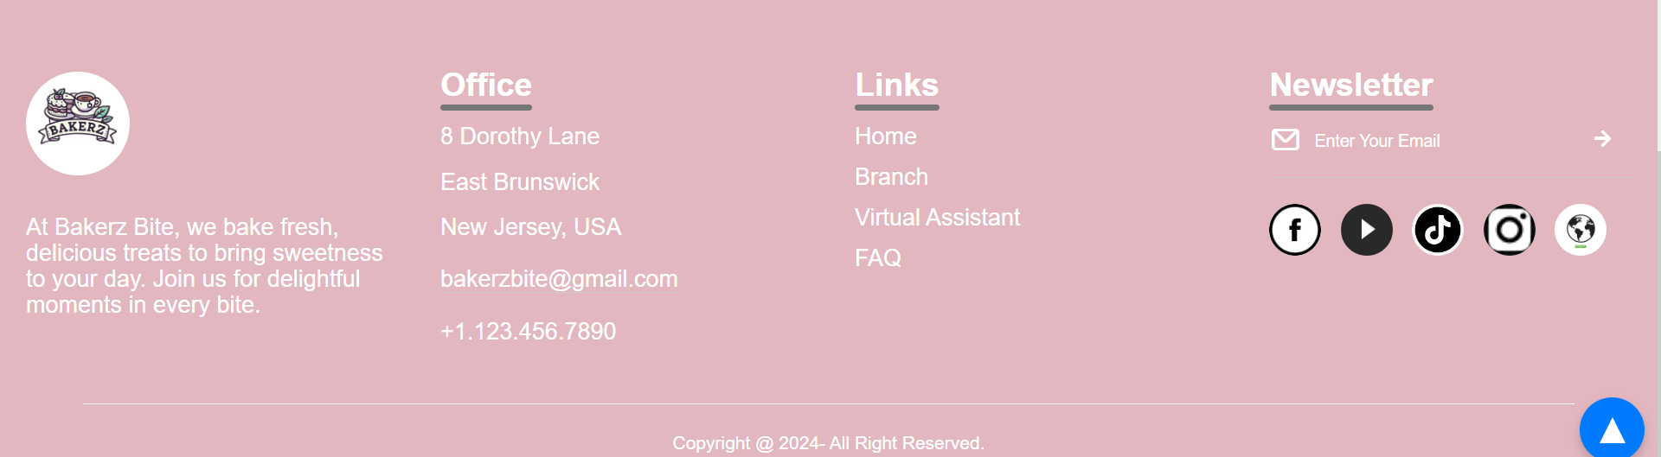

### Logo and Introduction

The Footer begins with the Bakerz Bite logo and a brief introduction: "At Bakerz Bite, we bake fresh, delicious treats to bring sweetness to your day. Join us for delightful moments in every bite."

### Office Information

The office address and contact information are clearly listed, making it easy for customers to reach out or visit:

* **Address:** 8 Dorothy Lane, East Brunswick, New Jersey, USA
* **Email:** bakerzbite@gmail.com
* **Phone:** +1.123.456.7890

### Useful Links

To facilitate navigation, the Footer includes links to important sections of the website:

* Home
* Branch
* Virtual Assistant
* FAQ

### Social Media

To foster community engagement and keep customers updated, the Footer features links to Bakerz Bite's social media profiles:

* Facebook
* YouTube
* TikTok
* Instagram

The Footer of the Bakerz Bite website serves as a comprehensive hub for essential information and links, ensuring customers can easily access what they need and stay connected with the bakery. This thoughtful design enhances user experience and strengthens the bond between Bakerz Bite and its customers.

**12.1. Links**

**12.1.1. Home**

When users click on the Home link in the Footer, they are seamlessly redirected to the homepage without the need to scroll back to the top of the page manually. This ensures a smooth and convenient navigation experience.

**12.1.2. Branch**

The **Branch** link in the Footer section of the Bakerz Bite bakery website is designed to provide detailed information about the various branches of the bakery in the USA. When users click on the Branch link, they are presented with two sections:

#### Left Section: Branch List

The left section displays a comprehensive list of all Bakerz Bite branches across the United States, including their addresses and phone numbers. This allows customers to quickly find the contact information for their nearest branch.

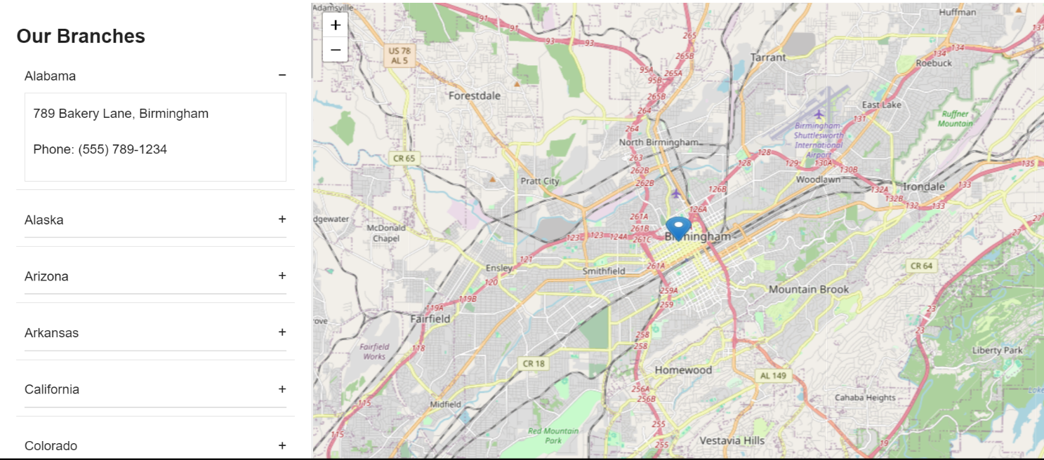

Example:

* **New York Branch**
  + Address: 789 Pie Avenue, Albany
  + Phone: (555) 789-1234
* **Alabama Branch**
  + Address: 789 Bakery Lane, Birmingham
  + Phone: (555) 789-1234

#### Right Section: Interactive Map

The right section features an interactive map that guides customers to the branches. The map provides an easy-to-use interface where customers can click on their state name, which is displayed on various tabs. Upon clicking, the map automatically zooms in to the selected state's location, highlighting the branch's position.

For example, if a customer in California clicks on "California," the map will zoom in to show the Bakerz Bite branch in California. This feature helps customers easily find directions and plan their visits to the bakery.

**12.1.3. FAQ**

When customers click on the **FAQ** link, they are directed to a dedicated **FAQ** page. This page is designed to be user-friendly, providing a well-organized layout that allows customers to easily browse through the questions and find the answers they need. Each question is linked to its detailed answer, making navigation straightforward and efficient. This ensures that customers can quickly get the information they are looking for, enhancing their overall experience on the Bakerz Bite website.

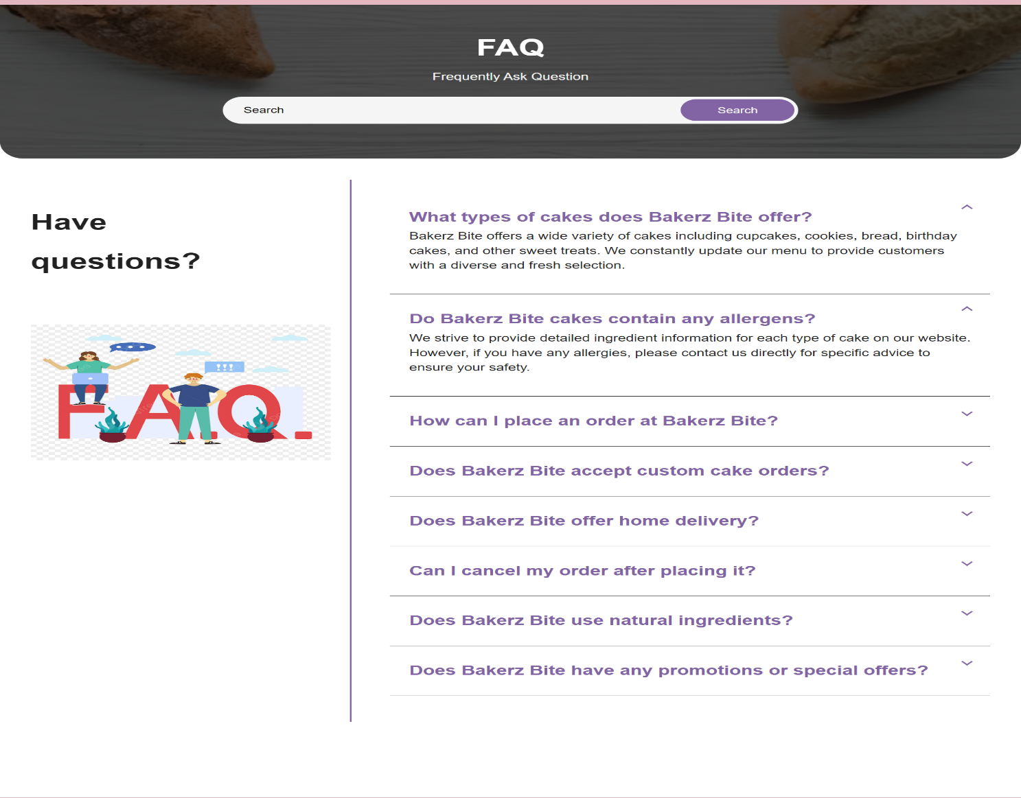

Customers can find the questions they are interested in by typing keywords into the search box. The results will be displayed immediately, and the keywords will be highlighted in yellow for easy identification.

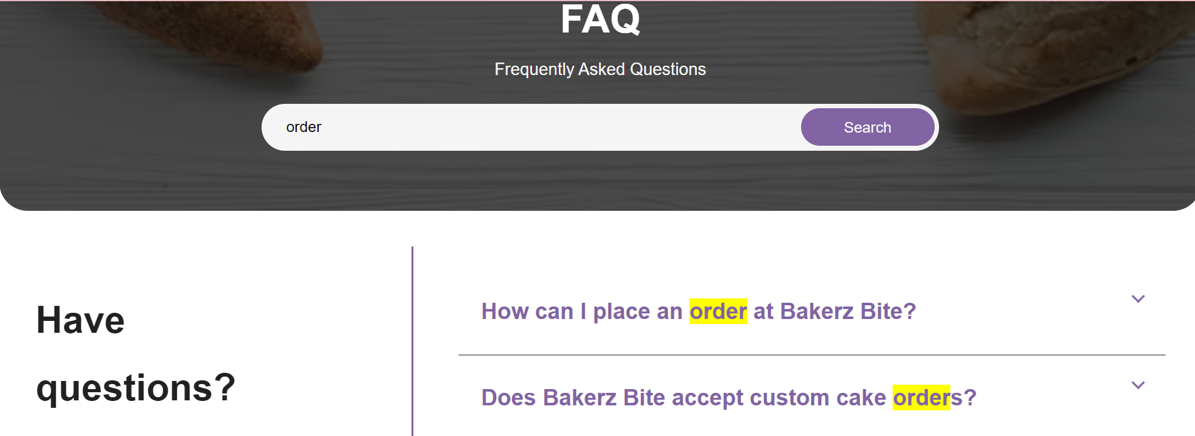

**12.1.4.Social Links**

The social media presence of Bakerz Bite allows customers to stay connected and engaged with the bakery in multiple ways. When users click on the icons for Facebook, YouTube, TikTok, or Instagram, they are directed to Bakerz Bite's respective social media pages. Each platform offers unique content, providing a comprehensive view of the bakery's offerings, community engagement, and latest updates.

**Facebook**

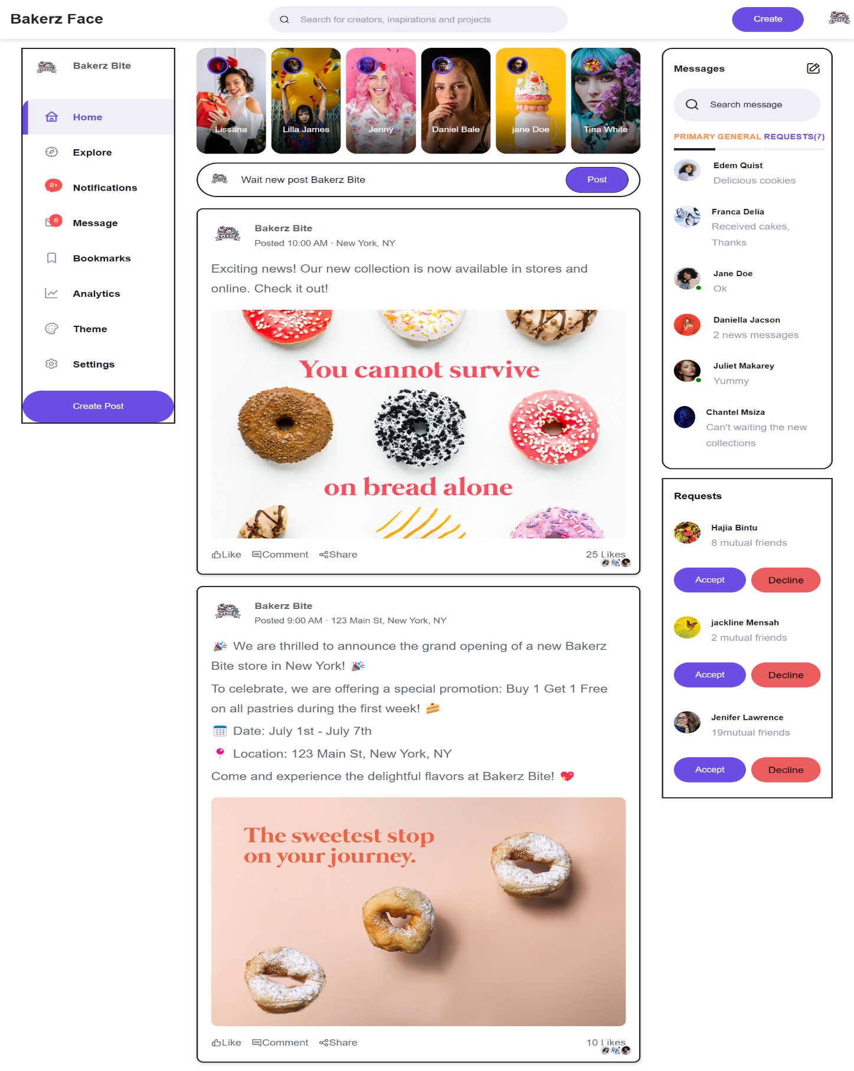

Clicking on the Facebook icon takes you to Bakerz Bite's Facebook page, where you can find a rich variety of content including announcements, promotions, customer reviews, and photos of our delicious products. Our Facebook page serves as a community hub, allowing customers to interact with us through comments and messages.

**YouTube**

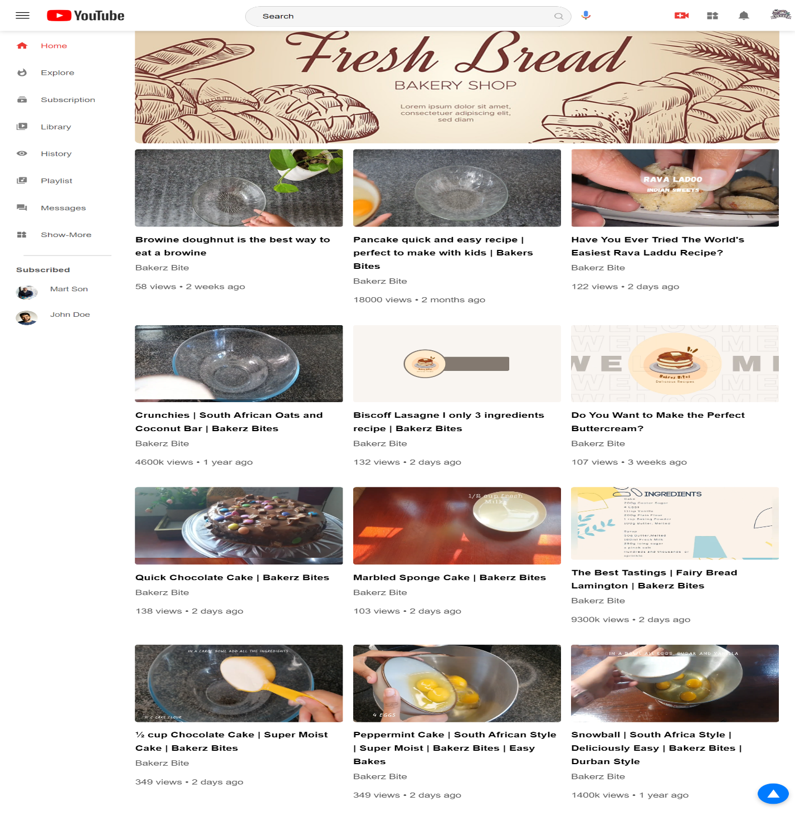

Our YouTube channel is the place to be for all video content related to Bakerz Bite. By clicking on the YouTube icon, you will find a collection of videos showcasing baking tutorials, cake decoration tips. We regularly post new recipes, how-to guides, and feature stories that highlight our commitment to quality and craftsmanship.

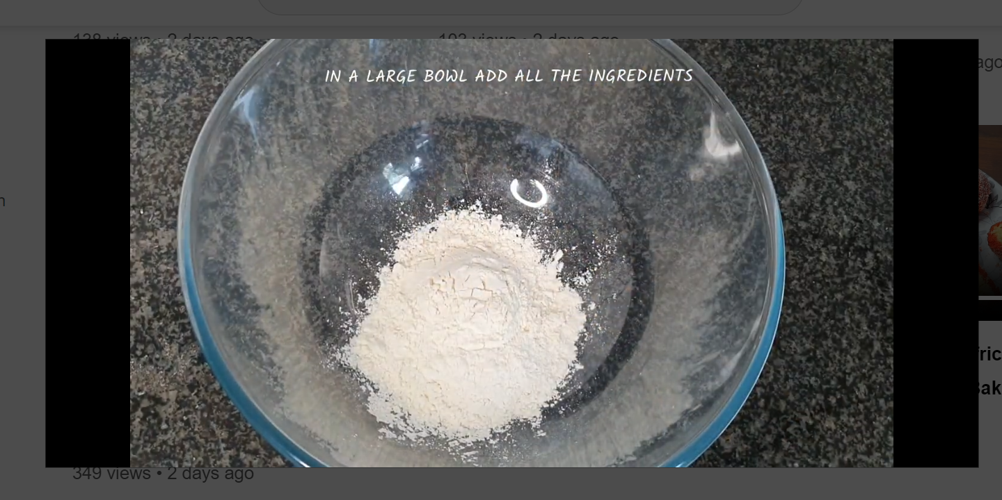

**TikTok**

Clicking on the TikTok icon will take you to our page filled with quick baking tips, trendy dessert ideas, and entertaining clips of our team at work. We love to participate in popular challenges and showcase our most visually appealing creations. Our TikTok content is designed to be both entertaining and informative, perfect for those looking for quick inspiration or a bit of bakery fun.

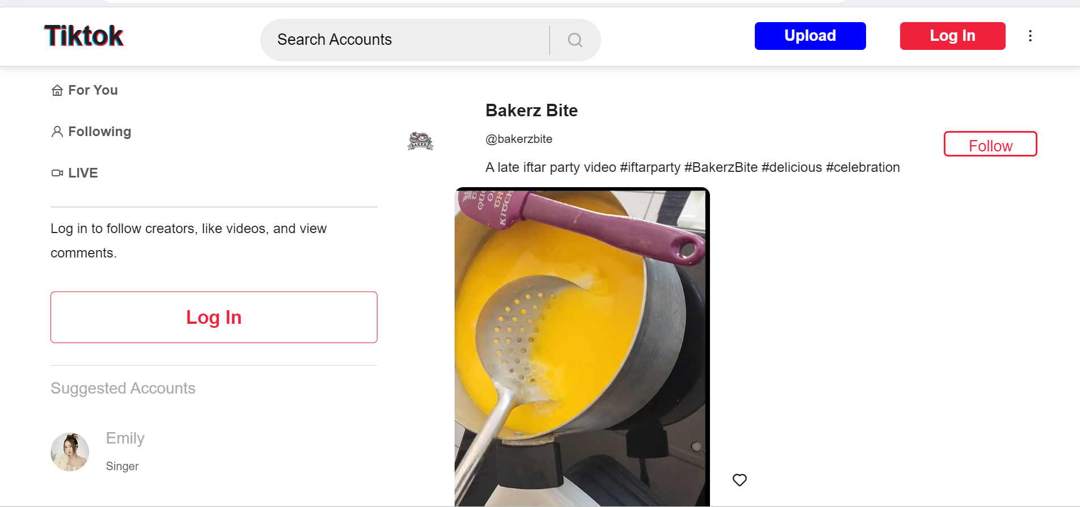

**Instagram** Our Instagram page is a visual feast for the eyes, featuring high-quality photos and stories of our mouth-watering cakes and pastries. By clicking on the Instagram icon, users can explore our beautifully curated feed, which includes everything from close-up shots of our intricate designs to customer testimonials and special promotions.

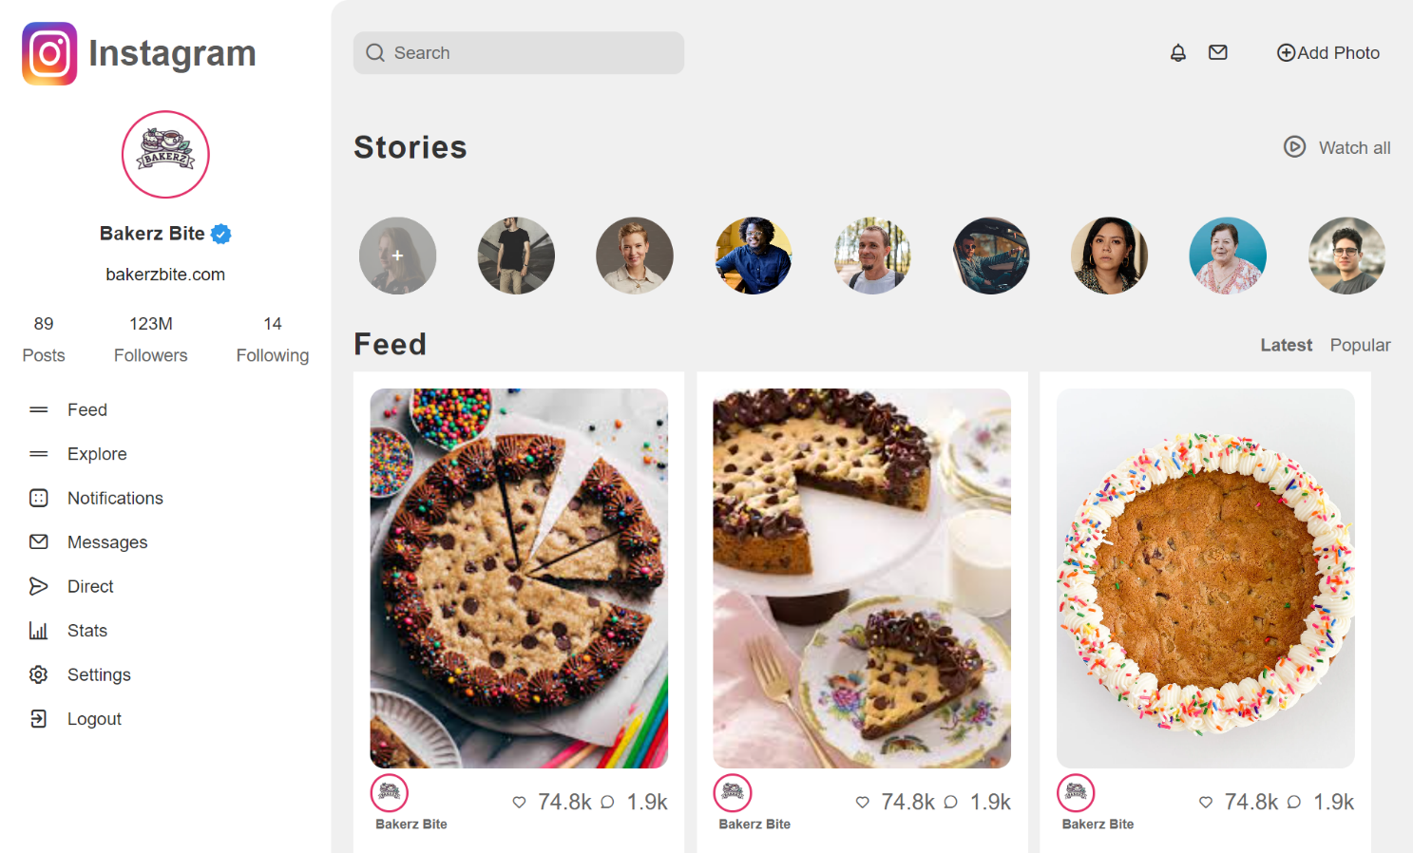

In conclusion, Bakerz Bite's diverse social media presence across Facebook, YouTube, TikTok, and Instagram effectively engages and connects with customers, enhancing their experience and fostering community loyalty.

**12.1.5. Virtual Assistant Page**

When customers access the virtual assistant page, they will encounter a chatbot. This chatbot will address all customer inquiries such as shipping policies, top-selling products, and can even automatically navigate to the page you request. There are two ways to use the virtual assistant: type your question into the input box or click on the microphone icon to ask. The chatbot, using AI voice will provide the answers you need.

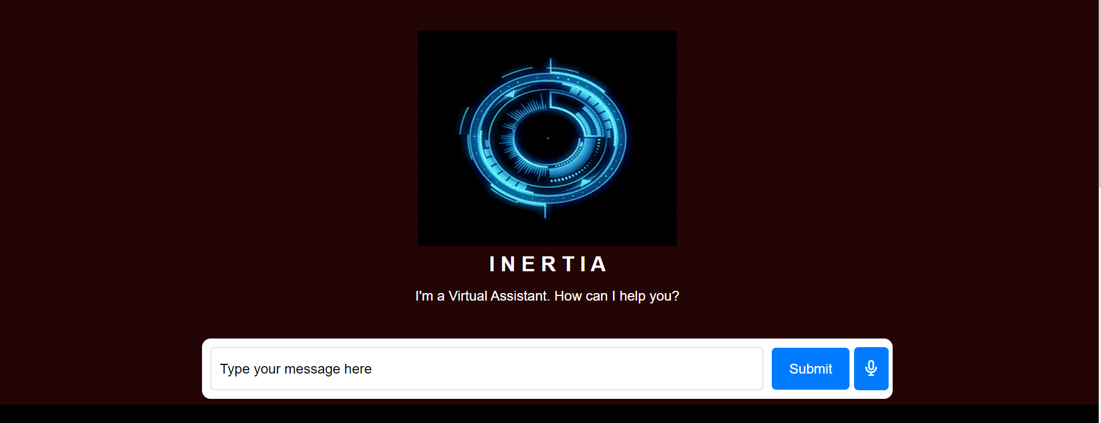

**XIII-Other Features**

**13.1. Back to top**

In the bottom right corner of the screen, there is an arrow button. When you click on it, it will take you to the top of the page without the need to use the scroll bar or mouse wheel.



**13.2. Display time date and location**

On the Bakerz Bite bakery website, a feature displays the current date, time, and the user's location. This ensures that users can see real-time information about the local time and date, making it easier for them to plan their visit to the bakery or to place orders according to the bakery's operating hours. The location feature also helps in providing accurate delivery options and times based on the user's geographical position.



**13.3. Translate**

On the Bakerz Bite website, users can translate content into various languages by clicking on the globe icon in the footer. This feature makes it easy for customers to understand and access information in their preferred language, creating a more convenient and user-friendly shopping experience. Whether you speak English, Spanish, French, or any other language, with just one click, the website will display content in your chosen language.

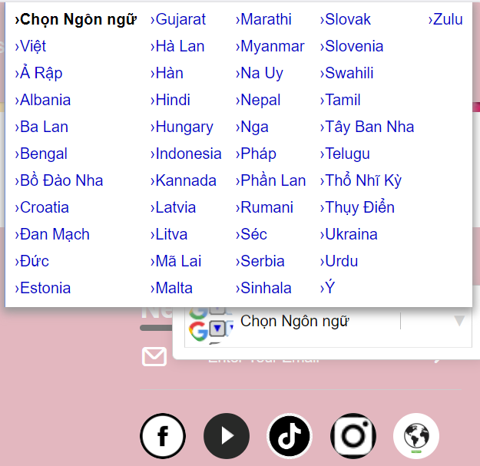

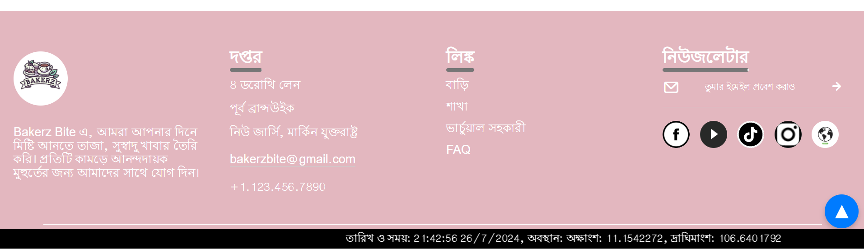

**Task Sheet**

|  |  |  |  |  |  |  |  |
| --- | --- | --- | --- | --- | --- | --- | --- |
| **No** | **Member** | | **Page Name** | **Planed Start Date** | **Actual Start Date** | **Actual End Date** | **Status** |
| *1.* | | *NGUYỄN HOÀNG ANH KHOA* | **Home** | 22/06/2024 | 23/06/2024 | 26/07/2024 | **100%** |
| **Facebook** | 22/06/2024 | 25/06/2024 | 26/07/2024 | **100%** |
| **Virtual Assistant** | 22/06/2024 | 25/06/2024 | 26/07/2024 | **100%** |
| **Blog** | 22/06/2024 | 01/07/2024 | 26/07/2024 | **100%** |
| **Branch** | 22/06/2024 | 01/07/2024 | 26/07/2024 | **100%** |
| **Order History** | 22/06/2024 | 01/07/2024 | 26/07/2024 |  |
| **Write document** | 22/07/2024 | 26/07/2024 | 26/07/2024 | **100%** |
| *2.* | | *NGÔ QUANG KHÁNH* | **Menu** | 22/06/2024 | 24/06/2024 | 26/07/2024 | **100%** |
| **Product** | 22/06/2024 | 24/06/2024 | 26/07/2024 | **100%** |
| **Youtube** | 22/06/2024 | 28/06/2024 | 26/07/2024 | **100%** |
| **Contact Us** | 22/06/2024 | 30/06/2024 | 26/07/2024 | **100%** |
| **Edit video** | 25/06/2024 | 30/06/2024 | 26/07/2024 | **100%** |
| **My Cake** | 25/06/2024 | 30/06/2024 | 26/07/2024 | **100%** |
| **Write document** | 22/07/2024 | 26/07/2024 | 26/07/2024 | **100%** |
| *3.* | | *LÊ VĨNH KHANG* | **Product Detail** | 22/06/2024 | 24/11/2023 | 26/07/2024 | **100%** |
| **Tiktok** | 22/06/2024 | 29/11/2023 | 26/07/2024 | **100%** |
| **About Us** | 22/06/2024 | 02/07/2024 | 26/07/2024 | **100%** |
| **Single page** | 22/06/2024 | 02/07/2024 | 26/07/2024 | **100%** |
| **Write document** | 22/07/2024 | 26/07/2024 | 26/07/2024 | **100%** |
| *4.* | | *NGUYỄN ĐỨC HUY* | **Checkout** | 22/06/2024 | 24/06/2024 | 26/07/2024 | **100%** |
| **Payment** | 22/06/2024 | 24/06/2024 | 26/07/2024 | **100%** |
| **Instagram** | 22/06/2024 | 24/06/2024 | 26/07/2024 | **100%** |
| **FAQ** | 22/06/2024 | 01/07/2024 | 26/07/2024 | **100%** |
| **User** | 19/07/2024 | 25/07/2024 | 26/07/2024 | **100%** |
| **Write document** | 22/07/2024 | 26/07/2024 | 26/07/2024 | **100%** |